Index of Facebook Recipe Collection # 2 by Page Number

- Strawberry Shortcake Bliss
- Copycat Peppermint Patties And Junior Mints
- Freezer Salsa
- Indian Frybread
- Wendy's Chili
- Peach Dumplings
- Italian Bake
- Berry Cobbler
- Ritz Crackers
- Baked Fried Chicken
- 2 Ingredient Cake
- Jalapeño Popper Dip
- Crisp Cucumber Salsa
- Mexican Stuffed Shells
- Breakfast Cheese Danish
- Almond Strawberry Pops
- Breakfast Bites
- Moist Zucchini Bread
- Ice Cream Bread
- Kfc Coleslaw
- Enchilada Bake
- Homemade Flour Tortillas
- Cherry Cheese Coffee Cake
- Easy Apple Cinnamon White Cake Loaf
- Rotel Cups
- Turtle Cheesecake Bars
- Sweet And Spicy Bacon Chicken
- Sweet Amish Macaroni Salad
- Coconut Cake Squares
- Apple Pie Baked In Apple
- Crockpot Chex Mix
- Coney Sauce For Hot Dogs
- Cowboy Casserole
- Dreamsicle Salad (Sugar Free)
- Homemade Honey-Based Ketchup
- Crazy Good Casserole
- Italian Shrimp Fettuccine
- Crockpot Potato Soup For Weight Watchers
- Mediterranean Grilled Chicken And Grape Skewers
- Caramel Apple Slices
- Buffalo Chicken Meatballs
- Baked Cheese & Broccoli Patties
- Fiesta Bubble Bread
- Loaded Baked Potato & Chicken Casserole
- Crispy Cheddar Chicken
- Pecan Chicken Salad
- Sugar Free Fudge
- S'mores Dip
- Pasta Fagioli Slow Cooker Crock Pot Version
- Million Dollar Pie
- Twice Baked Cheddar Potatoes
- Fudge Brownies
- Zucchini Fritters
- Mama's Creamy Baked Macaroni And Cheese
- Cheesecake Fruit Wraps
- Chicken Cordon Bleu Casserole
- Crockpot Meatloaf & Potatoes
- Two Minute Hawaiian Pie
- Million Dollar Spaghetti Casserole
- Strawberry Fudge
- Taco Pie
- Buttermilk Pie
- Sweet Potato Praline Casserole
- Almost Buttercream Frosting
- Breakfast Enchiladas
- Hawaiian Wedding Cake
- Not Yo Mama's Banana Pudding
- Skinny Pumpkin Cream Cheese Bars
- Philly® Blueberry Swirl Cheesecake
- Chocolate Suicide
- Four Layered Dessert
- Amish Cinnamon Bread
- Sweet Hawaiian Crock-Pot Chicken
- The Cheese Dip That Will Make You Famous
- Home Made Frappuccino
- Taco Pasta Salad
- Frozen Whoopie Pies
- Cinnamon Roll Cake
- Princess Pie (Coconut Cream Pie)
- Crockpot Cashew Chicken
- Breakfast Cheese Danish
- Easy Pizza Bubble Bread
- Strawberry Dream Squares
- Slow Cooker Bbq Pulled Pork Sandwiches
- The Best Spinach Artichoke Dip
- Broccoli Beef
- Sweet And Sour Chicken
- Chicken Cordon Bleu
- Homemade Hot Chocolate Mix
- Baked Manicotti
- Cheesy Au Gratin Potatoes
- Italian Bread Bowls
- Boston Clam Chowder
- Bbq Macaroni Salad
- Mexican Cornbread Layered Salad
- Mexican Rice
- Quick Chicken And Dumplings
- Sausage And Cheese Balls
- 3-Ingredient Sweet And Sour Meatballs

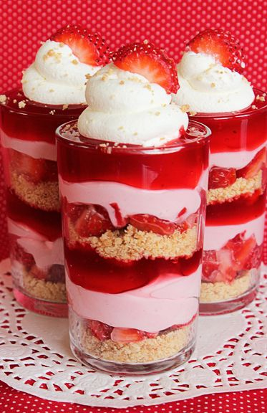
Strawberry Shortcake Bliss

1 carton fresh strawberries
1 can/bag Strawberry filling
1 packet of Duncan Hines® Frosting Creations™ Strawberry Shortcake Flavor Mix
1 can of Frosting Creations™ Frosting Starter
1 stick butter
1/4 pinch of salt
1 1/2 cup flour
1/4 cup granulated sugar
1 stick unsalted butter at room temp
whipped cream or heavy whipping cream

Step 1: Preheat oven to 275.
Step 2: Line 8X8 in pan with parchment paper.
Step 3: Cut butter into small bits.
Step 4: In a medium bowl mix flour, granulated sugar, and salt.
Step 5: With clean hands rub butter into dry ingredients.
Step 6: Pour mixture into lined pan. With a spatula or flat surface press the dough into the pan.
Step 7:. Bake at 275 for 30 minutes. Let cool. Shortbread should just being to darken.
Step 8: Using the parchment paper to lift from pan place shortbread in ziplock bag or bowl and crush finely.
Step 9: Mix Duncan Hines Frosting Creations Strawberry Shortcake Mix into Duncan Hines Frosting Starter.
Step 10: Cut strawberries into small chunks.
Step 11: In small bowls or dessert cups layer shortbread crumbs and press firm, then chopped strawberries, Duncan Hines icing, and strawberry filling repeating as needed. A piping bag is helpful for icing and filling.
Step 12: Top with whipped cream and strawberry slice if desired. I like to make my own by beating heavy whipping cream in a cold mixing bowl and sprinkling in just a little bit of powdered sugar.

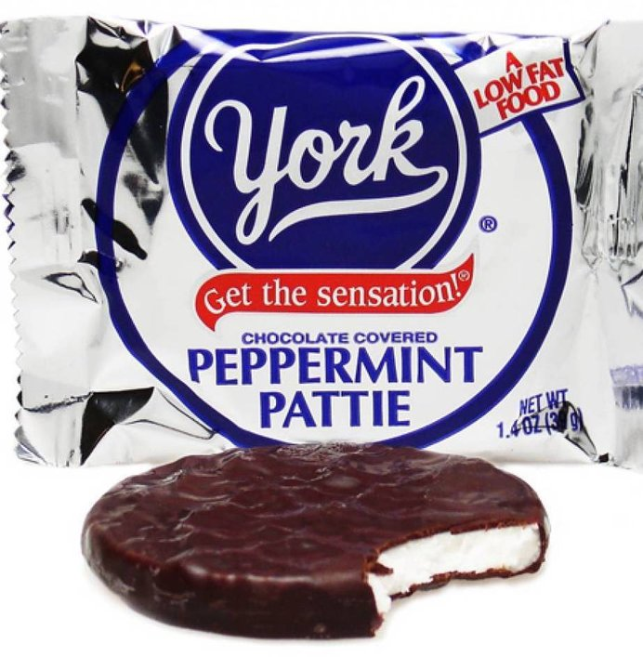

Copycat Peppermint Patties and Junior Mints

2 1/2 c. powdered sugar
1 1/2 T. light corn syrup, honey, or agave (your choice, they all work great!)
1 1/2 T. water
1 T. cream cheese (for the vegan option, simply omit the cream cheese. It is still plenty creamy without it!)
1/2 t. peppermint extract
1/4 t. vanilla extract
1 1/2 T. shortening
2 cups semisweet morsels (go darker if you prefer; 65-75% chocolate works great too.)
2 T. butter (or shortening if you want to go vegan.)

- Take out your bowl and dump in the powdered sugar, liquid sweetener of choice, water, shortening, cream cheese, peppermint and vanilla. Blend with and electric mixer until well blended (mixture will be crumbly.) Stir with a spoon to help it all cohere, using a bit of hand-power if necessary.
- Next, scoop the smooth white ball of dough onto your work surface that has been lightly dusted in powdered sugar (I used my trusty silpat.) Roll out until it is about 1/4 inch thick. Place in the freezer for 10 minutes.
- (Psst! in that time you can have all those dishes cleaned and dried! Just sayin’)
- Using your cookie cutter (or shot glass) punch circles into the dough, and put back into the freezer for another 10 minutes. While they are in the freezer, you’ll start to melt the chocolate. If you are using a double boiler, set it up and put the chocolate chips and shortening into the top and begin melting. If you are using a microwave, put your ingredients into a heat proof bowl and commence melting, heating at 30 second intervals on high and stirring in between until smooth and without lumps.
- When the chocolate is all melted and the patties are chilled, you’re ready to dip! Take the patties out of the freezer and let them sit for a minute to avoid breakage when transferring to dip. Get out a cookie sheet and line with wax or parchment paper. Peel off the circles and one by one drop them into the chocolate and smooth the tops, coating each thoroughly. Place them on the cookie sheet and keep going until they are all sufficiently swathed in chocolate. Put them in the freezer for about 20 minutes to allow the chocolate to set.
- For the ‘Junior Mints’ variation, simply gather up the odd shaped pieces and strips of dough leftover from the circle cutting process and roll them into small balls, flattening slightly on two sides to form the traditional junior mint shape. Pop them in the freezer for about 5 minutes to firm, and then dip them in the same manner as the circular mints. Chill until set.
- You know what to do now without this step: enjoy the fruits of your labor! These make a fantastic after meal sweet or an afternoon pick-me-up. Just be sure to store them in the fridge to keep the chocolate from getting really melty.

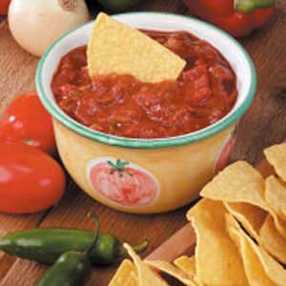

FREEZER SALSA

Ingredients
8 cups diced seeded peeled tomatoes (about 10 large)
2 medium green peppers, chopped
2 large onions, chopped
2 jalapeno peppers, seeded and finely chopped
3/4 cup tomato paste
2/3 cup condensed tomato soup, undiluted
1/2 cup white vinegar
2 tablespoons sugar
2 tablespoons salt
4-1/2 teaspoons garlic powder
1 tablespoon cayenne pepper

Directions
- In a Dutch oven or large saucepan, combine all ingredients. Bring to a boil. Reduce heat; simmer, uncovered, for 45 minutes, stirring often.
- Pour into small freezer containers. Cool to room temperature, about 1 hour. Cover and freeze for up to 3 months. Stir before serving. Yield: 10 cups.
Editor's Note: Wear disposable gloves when cutting hot peppers; the oils can burn skin. Avoid touching your face.
Nutritional Facts1 serving (1/4 cup) equals 23 calories, trace fat (trace saturated fat), 0 cholesterol, 386 mg sodium, 5 g carbohydrate, 1 g fiber, 1 g protein.

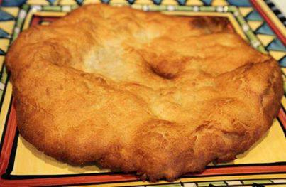
Indian Frybread
Ingredients:
4 cups of flour
1 tbs. baking powder
1 teaspoon salt
2 tbs. powdered milk
1 ½ cups warm water
1 cup shortening
Extra flour to flour your hands
Directions:
Put flour in bowl, add baking powder, salt and powdered milk. Mix.
Mix in warm water to form dough.
Cover hands in flour.
Knead dough by hand until soft but not sticky. Cover with a cloth and let stand for 15 minutes.
Shape dough into balls about 2 inches across then flatten by patting and stretching the dough.
Melt shortening about an inch deep in frying pan. When hot put dough in pan. Fry one side till golden brown, then turn and fry the other.
This is a wonderful bread that can be used as a dessert by topping with honey, powdered sugar, etc. or can be used for main dishes such as topping with taco ingredients for an "Indian Taco".

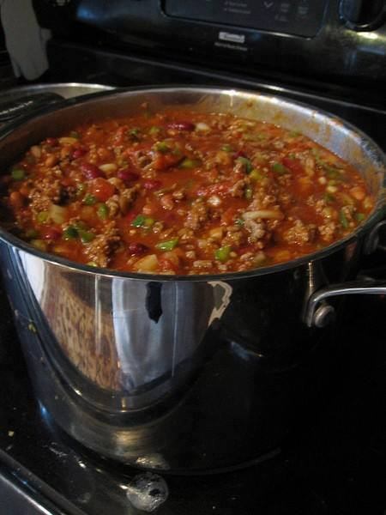
Wendy's chili
Ingredients:
2 pounds fresh ground beef
1 quart tomato juice
1 (29-ounce) can tomato purée
1 (15-ounce) can red kidney beans, drained
1 (15-ounce) can pinto beans, drained
1 medium-large onion, chopped (about 1 1/2 cups)
1/2 cup diced celery
1/4 cup diced green bell pepper
1/4 cup chili powder (use less for milder chili)
1 teaspoon ground cumin (use more for real flavor)
1 1/2 teaspoons garlic powder
1 teaspoon salt
1/2 teaspoon ground black pepper
1/2 teaspoon dried oregano
1/2 teaspoon sugar
1/8 teaspoon cayenne pepper
Instructions:
In a large skillet, brown the ground beef. Drain off the fat. Put the beef and the remaining ingredients in a 6-quart pot. Cover the pot and let the chili simmer for 1 to 1 1/2 hours, stirring every 15 minutes. You can also cook this in a slow cooker on low for 3 to 4 hours.

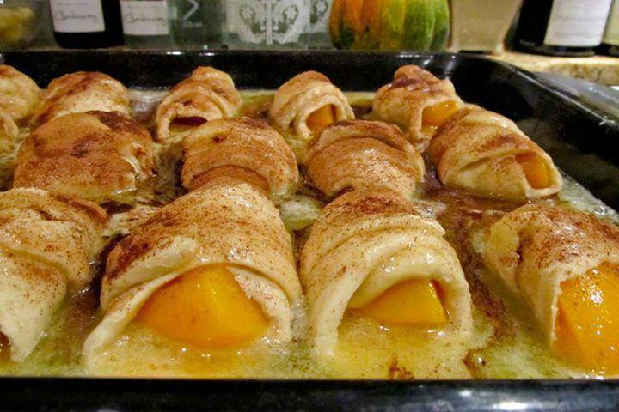
Peach Dumplings –
Ingredients:
2 whole large peaches
2 8 oz cans crescent rolls
2 sticks butter
1-1/2 cup sugar
1 tsp vanilla
cinnamon, to taste
1 12 oz can Mountain Dew
Peel and pit peaches. Cut both peaches into 8 slices. Roll each peach slice in a crescent roll. Place in a 9 x 13 buttered pan.
Melt butter, then add sugar and barely stir. Add vanilla, stir, and pour entire mixture over peaches. Pour Mountain Dew around the edges of the pan. Sprinkle with cinnamon and bake at 350 degrees for 40 minutes. Serve with ice cream, and spoon some of the sweet sauces from the pan over the top.

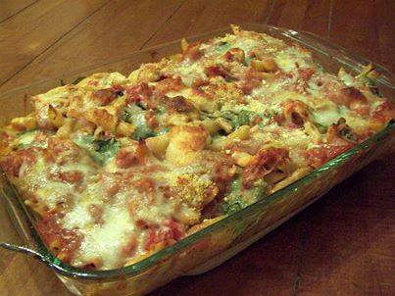
ITALIAN BAKE
3 pounds chicken breasts (cooked & cut into bite size pieces)
6 Italian sausage links
2 jars or spaghetti sauce (I use Hunt's in the can - cheaper & just as good!)
1 pound of pasta, penne, macaroni, shells or what ever you like
1 large package of pizza cheese
1 onion
2 large bell peppers - red & green, cut into chunks
Cut up chicken, onion, peppers and sausage.
Boil pasta and drain (don't over cook)
Mix pasta, sausage, onion, peppers, chicken and sauce.
Put in a large deep dish. If it won't all fit, make a little side dish to freeze for lunch later.
Top heavily with cheese.
Bake at 325 degrees for about 45 minutes or until golden and bubbly.

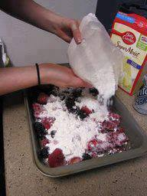
Berry Cobbler
Ingredients
Two 12-oz bags frozen mixed berries
1 box white cake mix (no pudding)
1 can of diet 7-up or sierra mist (clear soda)
Instructions
Place frozen fruit in a 9x13 baking dish. Add dry cake mix over the top. Pour soda slowly over cake mix. DO NOT stir the cake mix and the pop - this will give you a 'crust'. If you stir the two, you will hsve a cake like topping.
Bake 350 for 45-50 min.
You may be able to use frozen peaches instead of mixed berries.

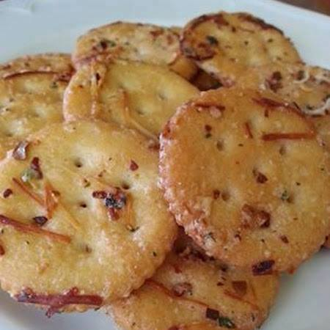

Ritz Crackers
1 stick melted butter,
1 packet Ranch dressing mix,
¼ c. grated Parmesan,
1 tbsp. red pepper flakes
1 tsp. garlic powder.
1 box Ritz crackers
~Directions
toss box of Ritz crackers with all 5 ingredients
Bake in 300 degree oven for 15 minutes

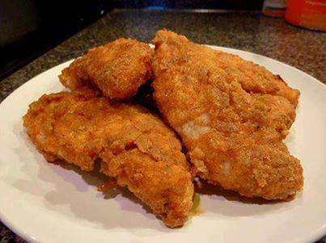
{Baked Fried Chicken}
I am pretty sure someone has discovered the KFC secret recipe! It is DEAD ON! It is also baked...not fried and there isn't any skin! So you get to enjoy the taste of the seasoning, instead of pulling it off because of the slimy skin!
This is super easy and you are TOTALLY going to love it!
Place thawed chicken breast tenderloin strips in a bowl of milk. Let soak for 20-30 min.
Mix in a Gallon Size Ziploc or Large Bowl:
1/2 tsp. Salt
1 T Season All
3/4 tsp Pepper
1 c. Flour
2 tsp. Paprika
Preheat oven to 400 degrees. Cut 1/2 stick of butter into a few pieces and place in a 9x13 pan. Melt butter in pre-heated oven.
Spread melted butter around the bottom of the pan. Lightly spray the pan, if needed, to make sure that there are no dry spots.

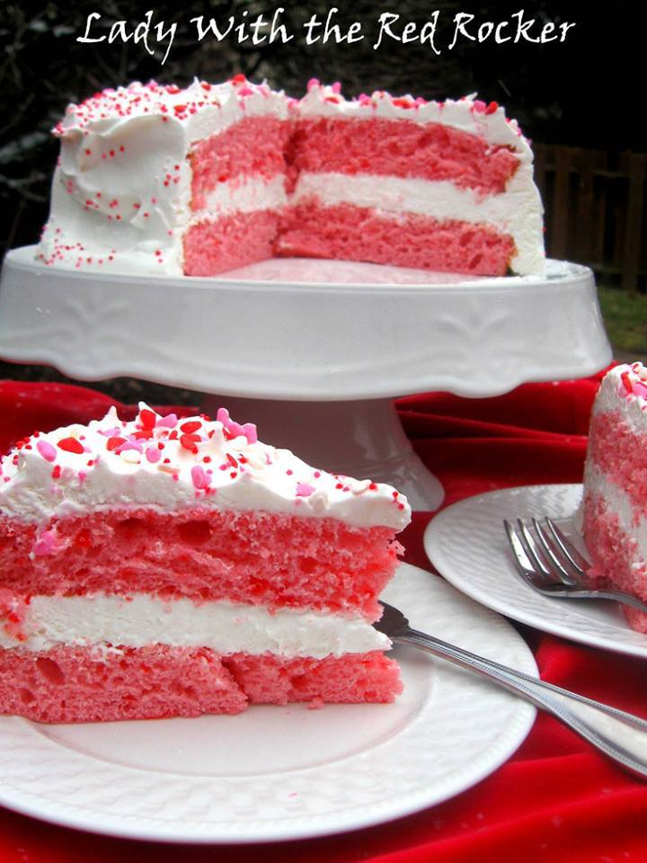

2 INGREDIENT CAKE
2 Ingredient Cake! Easy and low on calories! 1 box strawberry cake mix 12 oz. diet 7-up Combine the cake mix and the 7-up in a bowl and beat with an electric mixer until well blended. Bake as directed on box. (I decreased the temp to 325° and decreased the time by 5 minutes.) Cool and frost with Cool Whip or any frosting of your choice. Omg Yummy!

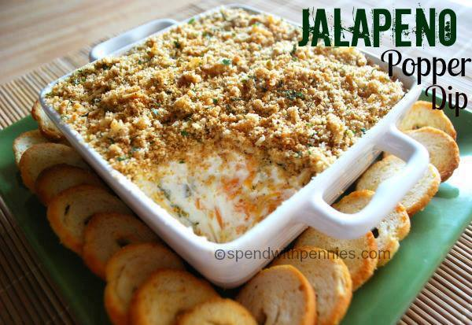
Jalapeño Popper Dip
Ingredients
1 4 oz can diced jalapenos, well drained OR 4-6 fresh jalapenos, roasted and diced (include seeds if you like it really spicy)
1 8 oz package cream cheese, softened
1 cup sour cream
2 cups shredded cheddar cheese
3/4 cup + 1/4 cup shredded parmesan cheese
1 cup Italian seasoned bread crumbs
4 tablespoons butter or margarine, melted
1 tablespoon dried parsley
Instructions
In a mixer or by hand, combine cream cheese and sour cream.
Add cheddar cheese, 3/4 cup parmesan cheese, and diced jalapenos, mix well.
Spoon into 8x8 baking dish, spreading evenly.
Blend bread crumbs, melted butter, 1/4 cup shredded parmesan cheese, and dried parsley, using a fork or your fingers, until crumbly.
Sprinkle the buttery crumb topping evenly over the cream cheese mixture.
Bake at 350 degrees for 15 minutes, or until hot and breadcrumbs are golden brown. Do not overcook.
Serve with bread or crackers...

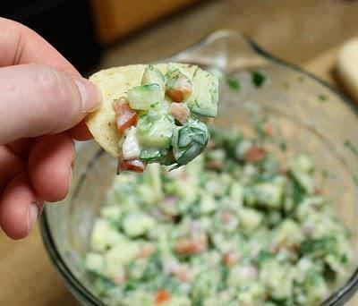
Crisp Cucumber Salsa:
Note: 1/4 cup is only 16 calories! YES ONLY 16 Calories!!!
2 cups finely chopped seeded peeled cucumber
1/2 cup finely chopped seeded tomato
1/4 cup chopped red onion
2 Tbsp minced fresh parsley
1 jalepeno pepper, seeded and chopped
4-1/2 tsp minced fresh cilantro
1 garlic clove, minced or pressed
1/4 c reduced-fat sour cream
1-1/2 tsp lemon juice
1-1/2 tsp lime juice
1/4 tsp ground cumin
1/4 tsp seasoned salt
Tortilla chips
In a small bowl, combine the first seven ingredients. In another bowl, combine the sour cream, lemon juice, lime juice, cumin and seasoned salt. Pour over cucumber mixture and toss gently to coat. Serve immediately with chips.

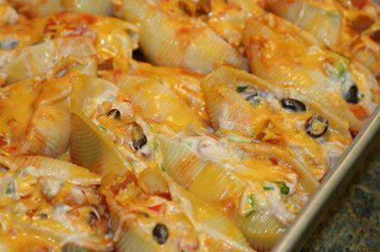
Mexican Stuffed Shells
Yield: 16 shells
Ingredients
1 pound ground beef (or ground turkey)
1 package low-sodium taco seasoning
4 ounces cream cheese
16 jumbo pasta shells
1 1/2 cups salsa
1 cup taco sauce
1 cup cheddar cheese
1 cup Monterrey jack cheese
For toppings:
3 green onions
Sour cream
Instructions
Preheat oven to 350°.
In a pan brown the ground beef; add taco seasoning and prepare according to package directions. Add cream cheese, cover and simmer until cheese is melted. Stir together and mix well. Set aside and cool completely.
While ground beef is cooking, cook the pasta shells according to package directions; drain. Set shells out individually on cutting board or baking sheet so that they don’t stick together.
Pour salsa on bottom of a 9?13 baking dish. Stuff each shell with 1-2 tablespoons of the meat mixture. Place shells in 9?13 pan open side up. Evenly cover shells with taco sauce. Cover dish with foil and bake for 30 minutes.
After 30 minutes, add shredded cheese and bake for 10-15 more minutes with the foil removed. Top with green onions or olives if desired. Serve with sour cream and/or more salsa.

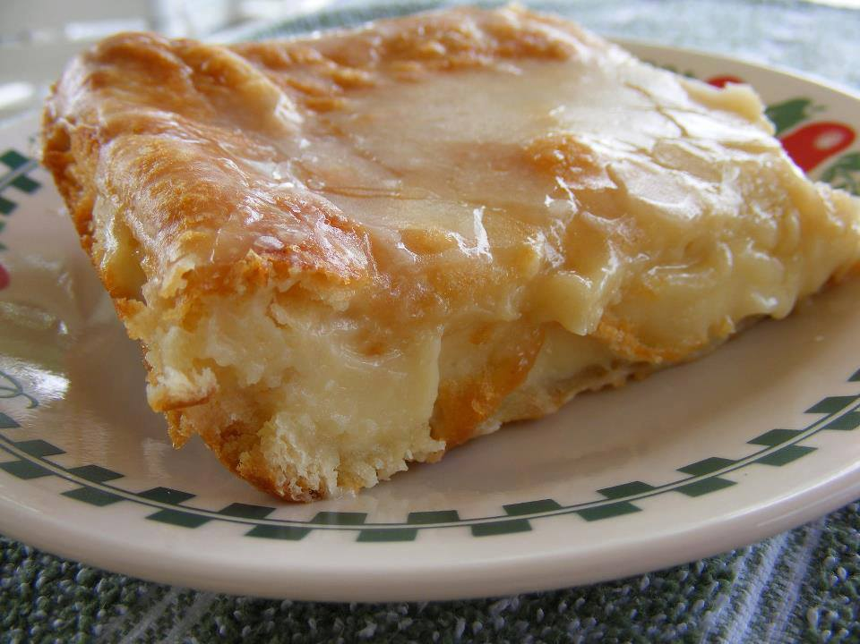
Breakfast Cheese Danish
2 cans ready to use refrigerated crescent rolls
2 (8-ounce each) packages cream cheese
1 cup sugar
1 teaspoon vanilla extract
1 egg
1 egg white
Glaze:
1/2 cup powdered sugar
2 Tablespoons milk
1/2 teaspoon vanilla extract
Preheat oven to 350* degrees and grease a 13X9-inch baking pan. Lay a pack of crescent rolls in the pan and pinch the openings together. Beat the cream cheese, sugar, vanilla, and egg together until smooth. Spread the mixture over the crescent rolls evenly and then lay the second pack of crescent rolls on top of the cheese mixture and brush with egg white. Bake for 35-45 minutes until the top is golden brown. Top with glaze after cooling for 20 minutes.

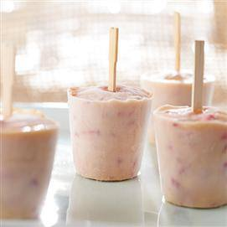
Almond Strawberry Pops

Yield: 4 pops

1 (6 oz.) container vanilla flavored yogurt
2 tablespoons Jif® Creamy Almond Butter
2 tablespoons almond milk
2 teaspoons agave nectar
1/2 cup finely chopped strawberries
4 (3 oz.) disposable plastic cups
4 wooden craft sticks

WHISK yogurt, almond butter, almond milk and agave nectar until smooth. Stir in strawberries. Divide mixture evenly into cups. Insert sticks. Freeze 3 hours or until firm. Warm cup with hands before removing pops.

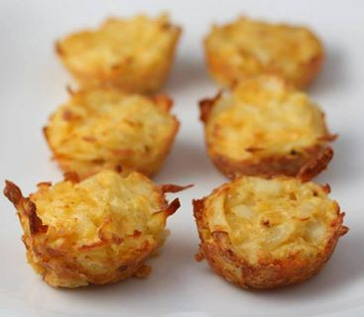
Breakfast Bites—
25 minutes to perfection.

What you need:
1 package of pre-shredded potatoes (refrigerated section next to the eggs)
3 eggs, beaten
1/2 cup shredded cheddar cheese
1/4 finely chopped onion (optional)
1/4 teaspoon garlic powder
salt and pepper to taste.

Preheat oven to 350 degrees and grease a mini muffin pan. Pour potatoes into a bowl, add the salt, garlic powder and onion, stir to combine. Pour in the egg and give it another stir, then add the cheese and mix it all up. Spoon into mini muffin tins and bake for 20 – 25 minutes or until golden brown and tops and edges begin to get crispy. Eat warm, or cool and freeze into individual packs and heat for about 20 seconds in the microwave. Breakfast is made for the whole week!

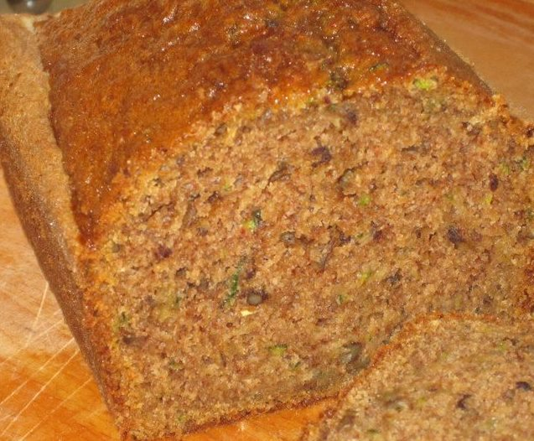
Moist Zucchini Bread
"This recipe makes two loaves."
Ingredients:
3 cups all-purpose flour
1 teaspoon salt
1 teaspoon baking soda
1 teaspoon baking powder
3 teaspoons ground cinnamon
3 eggs
1 cup vegetable oil
2 1/4 cups white sugar
3 teaspoons vanilla extract
2 cups grated zucchini
1 cup chopped walnuts
Directions:
1. Grease and flour two 8 x 4 inch pans. Preheat oven to 325 degrees F (165 degrees C).
2. Sift flour, salt, baking powder, soda, and cinnamon together in a bowl.
3. Beat eggs, oil, vanilla, and sugar together in a large bowl. Add sifted ingredients to the creamed mixture, and beat well. Stir in zucchini and nuts until well combined. Pour batter into prepared pans.
4. Bake for 40 to 60 minutes, or until tester inserted in the center comes out clean. Cool in pan on rack for 20 minutes. Remove bread from pan, and completely cool.

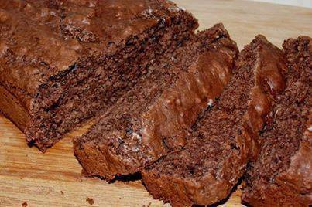
ICE CREAM BREAD
Only 2 ingredients!
Who out there has ever made ice cream bread? If you haven't, what are you waiting for? You use only two ingredients and two steps. All you have to do is mix self-rising flour with softened ice cream of choice and bake. Poof! You have bread!
You need ice cream that is not sugar free or low fat...just regular full fat ice cream. This one is made with just chocolate but just imagine how awesome a loaf of Ben and Jerry's Rocky Road or Cherry Garcia bread could be. I have made it with Chunky Monkey and it is delicious. I will include that recipe too so you can try it. Go with bold flavors of ice cream such as peanut butter or butter pecan. Don’t forget, you can also add extra ingredients into the mix to make it less plain and more flavorful. Experiment and have fun with it!
Ice Cream Bread
2 cups of your favorite ice cream, softened
1 and 1/2 cups of self rising flour
Preheat your oven to 350 degrees. Grease and flour an 8×4 inch loaf pan. Mix the ice cream and flour together in a bowl just until combined. Smooth it out so it looks even. Bake for 45 minutes or until toothpick inserted comes out clean. Cool for a while and then serve.
Chunky Monkey Ice Cream Bread (2 loaves or 1 large loaf)
2 pints Ben & Jerry's Chunky Monkey, softened or melted
3 cups self-rising flour
1 very ripe banana, chopped
1 chocolate bar, chopped
Handful of walnuts, chopped
Preheat oven to 350 degrees. Grease and flour bread pan, or line with parchment paper. Mix melted ice cream and flour until well combined. Add chocolate, banana and nuts. Pour into prepared bread pan. Bake for 45 minutes per loaf or 60-90 minutes for a larger double loaf. If the top starts to brown too much, cover it with aluminum foil and continue to bake. The bread is done when a skewer inserted into the middle comes out clean.

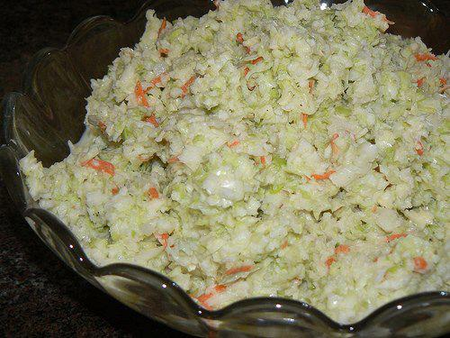
KFC COLESLAW
Ingredients:
1/2 cup mayonnaise
1/3 cup sugar
1/4 cup milk
1/4 cup buttermilk
2 1/2 tablespoons lemon juice
1 1/2 tablespoons white vinegar
1/2 teaspoon salt
1/8 teaspoon pepper
8 cups finely chopped cabbage (approx. 1 head)
1/4 cup shredded carrot (1 medium carrot)
2 tablespoons minced onion
Directions:
* Be sure cabbage and carrots are chopped into very fine pieces (a little bigger than rice)
* Combine the mayonnaise, sugar, milk, buttermilk, lemon juice, vinegar, salt and pepper in large bowl. Beat until smooth
* Add cabbage, carrots, and onions. Mix well.
* Cover and refrigerate for at least 2 hours, if you let it sit over night it's even better

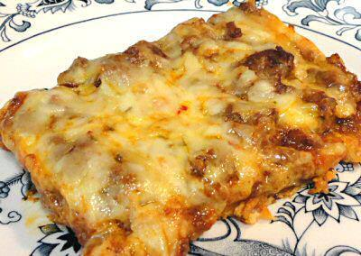
ENCHILADA BAKE
Crust:
4 ounces cream cheese, softened
2 eggs
1/2 teaspoon Taco Seasoning
8 ounces cheddar cheese, shredded
1/4 ounce tortilla chips, finely crushed *
Beat or whisk the cream cheese and eggs until smooth. Add the seasoning; mix well. Stir in the cheese and crushed chips; mix well. Grease a 9x13" baking dish or line with parchment paper; spread the cheese mixture evenly over the bottom. Bake at 350º, 35 minutes or until browned, but not too dark. Let stand 5-10 minutes before adding the topping.
* 1/4 ounce is about 4-5 small round tortilla chips. I used the unflavored white corn kind. They only add about 4 carbs to the whole recipe.
Topping:
1 pound ground beef
1 tablespoon Taco Seasoning
1/2 batch Red Enchilada Sauce (about 1 cup)
8 ounces pepper-jack cheese, shredded
Brown the hamburger; drain fat. Stir in the seasoning and enchilada sauce. Spread over the crust. Top with the cheese. Bake another 20 minutes or so until hot and bubbly.
Makes 8 servings
Per Serving: 414 Calories; 32g Fat; 27g Protein; 5g Carbohydrate; 1g Dietary Fiber; 4g Net Carbs
The addition of the tortilla chips makes a big difference in this dish and adds less than a carb per serving. I was making the crust for my Enchilada Bake recipe and threw the crushed chips in on a whim. I wasn't even sure if such a tiny bit would be noticeable but was pleasantly surprised to find that they add a nice corn tortilla flavor.

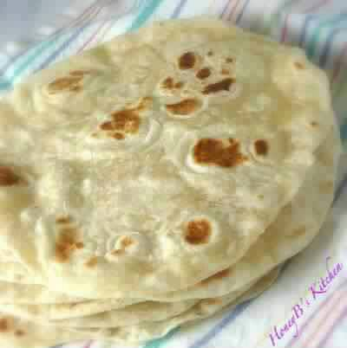
HOMEMADE FLOUR TORTILLAS:
3 cups flour
1 tsp salt
1 tsp baking powder
1/3 cup oil
1 cup warm water
Combine all ingredients until it forms a dough. Roll into a big ball and take about 1"-2" pieces off. Pat flat with your hands or use a rolling pin. Put on a griddle on the stove and let the sides cook until there are lil brown specks.

Cherry Cheese Coffee Cake ( pampered chef book)
Cake & filling
2 (8 oz. each) pkgs. refrigerated crescent rolls
8 oz. cream cheese
1/4 cup powdered sugar
1 egg
1/2 tsp. vanilla or almond extract
21 oz. can cherry pie filling
Glaze
1/2 cup powdered sugar
2-3 teaspoons milk
Preheat oven to 350 degrees F. Unroll crescent dough and arrange 12 of the triangles in a circle with wide ends toward the outside edge of the Large Round Stone - the points will not meet in the center. Lightly flour and roll out the seams making a 14" circle with a 3" hole in the center. Combine the cream cheese, powdered sugar, egg & vanilla and spread over dough. Top with pie filling. Cut each of the 4 remaining triangles into thirds (starting at the wide end opposite the point and cutting lengthwise to the point). Arrange over filling evenly in spoke-like pattern. Press ends to seal at center and outer edges. Bake 25-30 minutes or until golden brown. Cool slightly. Mix powdered sugar and milk until glaze consistency and drizzle over coffee cake.

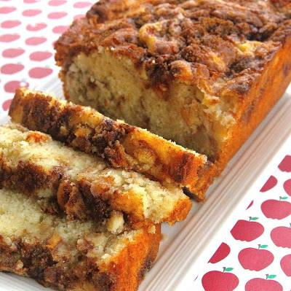
Easy Apple Cinnamon White Cake Loaf
makes 1 9x5-inch loaf
Ingredients:
1/3 cup brown sugar
1 teaspoon ground cinnamon
2/3 cup white sugar
1/2 cup butter, softened
2 eggs
1 1/2 teaspoons vanilla extract
1 1/2 cups all-purpose flour
1 3/4 teaspoons baking powder
1/2 cup milk
1 apple, peeled and chopped
Instructions:
Preheat oven to 350 degrees F (175 degrees C). Grease and flour a 9x5-inch loaf pan.
Mix brown sugar and cinnamon together in a bowl.
Beat white sugar and butter together in a bowl using an electric mixer until smooth and creamy. Beat in eggs, 1 at a time, until incorporated; add vanilla extract.
Combine flour and baking powder together in a bowl; stir into creamed butter mixture. Mix milk into batter until smooth. Pour half the batter into the prepared loaf pan; add half the apples and half the brown sugar mixture. Lightly pat apple mixture into batter. Pour the remaining batter over apple layer; top with remaining apples and brown sugar mixture. Lightly pat apples into batter; swirl brown sugar mixture through apples using a finger or spoon.
Bake in the preheated oven until a toothpick inserted in the center of the loaf comes out clean, 30 to 40 minutes.

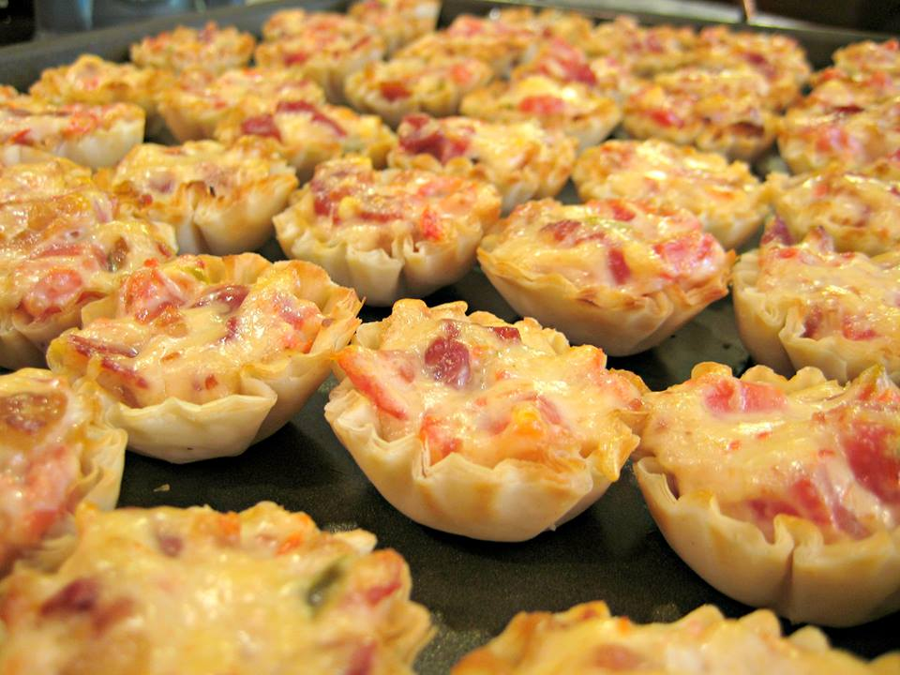
Perfect tailgate food!! Or a great appetizer for a party!!
Rotel Cups
Makes: 45 cups
Ingredients:
1 Can rotel tomatoes, drained (almost all the way)
1 bag bacon pieces
1 cup shredded swiss
1 cup Mayo
3 pkg. phyllo pastry cups – thawed
Directions:
Preheat oven to 350 degrees F.
Mix the first 4 ingredients and scoop evenly into the cups. Place on baking sheet and cook at 350 for 15 min.

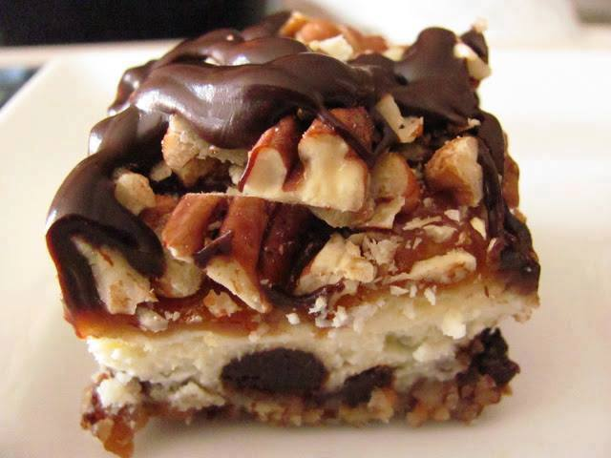
Turtle Cheesecake Bars
Turtle Cheesecake
Crust
3 cups finely chopped pecans
1 stick unsalted butter, melted
1/3 cup sugar
1/4 teaspoon salt
Cheesecake Filling
24 oz cream cheese, softened
1/4 cup full-fat Greek yogurt or sour cream
3/4 cup sugar
1 tablespoon vanilla
3 large eggs
1 cup semi-sweet chocolate chips
Toppings
1 cup coarsely chopped pecans, toasted
1 11-oz bag caramel candy, unwrapped
1 cup semi-sweet chocolate chips
6 tablespoons milk, divided
Preheat oven to 300 degrees.
Line a 13x9 pan with parchment paper, so that parchment extends over long side of pan.
In a bowl, mix crust ingredients together with a fork; press mixture onto bottom of prepared pan.
Bake crust for 20 minutes; while crust bakes, prepare filling.
Cream together cream cheese, yogurt or sour cream, sugar and vanilla.
Beat in eggs, one at a time.
After crust bakes, remove from oven and immediately sprinkle on 1 cup of semi-sweet chocolate chips.
Pour filling over chocolate chips and return to oven; bake for 50 minutes.
Allow cheesecake to cool for about hour, then place in refrigerator to chill overnight.
When ready to serve, remove cheesecake from pan using parchment paper and place on serving platter, then prepare toppings:
Toast pecans in oven for 10 minutes at 350 degrees.
Unwrap caramels and place in a microwave safe bowl, along with 4 tablespoons milk.
Microwave in 30 second intervals until caramels have melted and sauce is smooth.
Pour caramel sauce over cheesecake and immediately sprinkle on toasted and chopped pecans.
Place chocolate chips in a microwave safe bowl, along with 2 tablespoons milk, and microwave in 30 second intervals, about 2 minutes total.
Stir until smooth and drizzle over caramel-pecan topping.
Allow chocolate to set before serving.

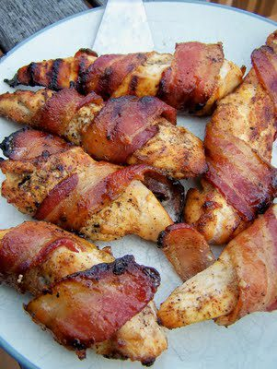
Sweet and Spicy Bacon Chicken
4 chicken breasts cut in thirds (12 pieces)
Bacon slices
salt and pepper to taste
garlic powder
chili powder
brown sugar
Cut each breast into 3 pieces, season all the chicken with the spices, then wrap a bacon slice around each piece, roll in brown sugar and place into an oven proof dish....make sure you have some olive oil in the dish too, like 2 or 3 tablespoons is fine {I skipped this since I grilled them. I honestly think you could coat your dish with nonstick cooking spray instead to save a few calories}.
Bake at 400 degrees for 30 to 40 minutes or until chicken is cooked through and bacon is nice and brown and crispy. Delicious served with mashed potatoes with some of the gravy from the chicken drizzled on top.
**Also great on the grill! No juices to drizzle on anything, but still delicious!

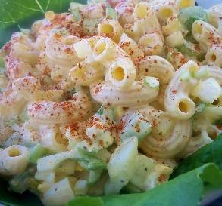
Sweet Amish Macaroni Salad:
"Absolutely the BEST macaroni salad! The mayo mixture is what makes it so delightful — that bit of sweetness
Ingredients:
Servings:
12-15
1 lb salad macaroni
4 hard-boiled eggs (chopped)
1 small onion, finely diced
3 celery ribs, diced small
1 small sweet pepper, seeded and diced small (red or orange)
dressing
2 cups light mayonnaise (do not use Miracle Whip)
1/2 cup sugar
1/8 cup yellow mustard
2 tablespoons dill pickle relish
1 tablespoon white vinegar or 1 tablespoon apple cider vinegar
3/4 teaspoon celery seed
1/4 teaspoon salt
paprika (to garnish)
Directions:
1
Cook the macaroni according to directions, drain well.
2
While pasta is cooking mix up all the dressing ingredients till well blended and set aside.
3
Chop up all the veggies.
4
When macaroni has cooled and drained well mix in the dressing (add all of it if you like very creamy salad.if you don't like a lot of dressing leave out about 1/2-3/4 c of the dressing. Remember that as it sets it will soak up some of the dressing.
5
Refrigerate for at least one hour, the longer you let it set the better the flavor. Overnight is not to long! Servings are approximately Does not include cook time or the chill time.

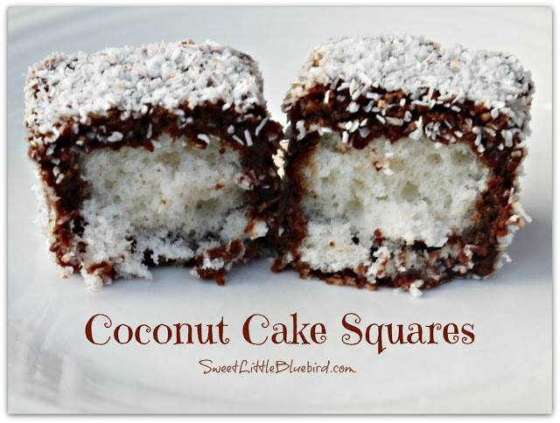
Coconut Cake Squares
Ingredients
1 Box of White Cake - Bake according to package in a 9x13 baking dish
lined with foil and sprayed with non-stick cooking
spray.
1 cup Hershey's Cocoa (unsweetened)
1 1/4 cup Sugar
2 cups Water
2 cups Fine Macaroon Coconut
Directions - (see important tips below)
Bake cake as directed and cool. Place cake in freezer until frozen.
In a sauce pan, mix cocoa, sugar and water and bring to a boil over low heat. Boil for 5 minutes, stirring often (mixture will be thin). Cool to room temperature. Next, remove cake from freezer and cut into squares or bars. Dip the squares one by one in the chocolate mixture, completely coating the cakes, then place on cooling rack to drain. Next, roll the cakes in coconut, being sure to coat the entire surface of the squares well. Place finished cakes in tupperware or on a cookie sheet or baking dish - be sure to line whatever you use with wax paper. You can stack the coconut squares by placing wax paper in between the layers. Place cakes back in freezer. Remove from freezer 30 minutes before serving. ENJOY!
Important Tips
When baking the cake, line the entire baking dish with foil, leaving enough foil over the edge so you can grab it after baking and freezing. Be sure to coat the foil well with non-stick cooking spray. You do not need to flour the foil.
Cut the cake while it's still frozen. Remove the frozen cake from the pan by grabbing the foil, lifting and placing it on a flat surface for cutting (cookie sheet or cutting board).
When working with the cake squares, you need to move fast! You want to work with the cake while it's frozen, otherwise the cake will start to fall apart when dipping. Try doing FOUR at a time - dip in chocolate mixture, drain and quickly roll them in coconut. Two forks work great when dipping and rolling them. Also, place some wax paper or paper towel under your cooling rack to catch the chocolate dripping below.
To help keep the cake frozen, cut the cake in half, leaving the other half in the freezer. Finish the first half (dipping and coating), then pull out the other half of the cake when ready.
You can bake the cake a few days ahead of making the bars. You can also make the chocolate mixture a day head and store it in the fridge. Be sure to stir well before dipping.

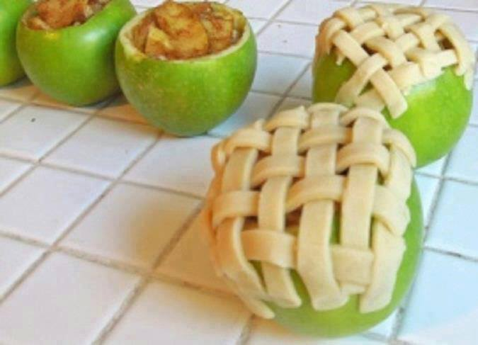
~ APPLE PIE BAKED IN APPLE ~
Ingredients:
5-6 Granny Smith apples (make sure they can stand on their own)
1 tbsp. cinnamon
1/4 cup sugar
1 tbsp. brown sugar
pie crust (homemade or pre-made)
Directions:
1) Preheat oven to 375F.
2) Cut off the top of 4 apples off and discard. Remove the inside of each apple with a spoon or melon baller very carefully, as to not puncture the peel. If you’re a skilled interior apple excavator, salvage as much as you can so you can use it for Step 2. I, on the other hand, am not skilled so I just had to throw my interior apples away and chop up additional apples for filling.
3) Remove skin from remaining apple(s) and slice very thinly. These apple pieces will give you the additional filling needed to fill the four apples you are baking. Mix sliced apples with sugars and cinnamon in a bowl. If you prefer more or less cinnamon make adjustments as desired. Same goes for the sugar. Scoop sliced apples into hollow apples.
4) Roll out pie crust and slice into 1/4 inch strips. You can also add a strip of pastry inside the top of the apple almost like a liner to add a little more texture/sweetness to the pie. Cover the top of the apple in a lattice pattern with pie crust strips.
5) Place apples in an 8×8 pan. Add just enough water to the cover the bottom of the pan. Cover with foil and bake for 20-25 minutes. Remove foil and bake for an additional 20 minutes or until crust is golden brown and sliced apples are soft.
Makes 4 baked apple pies (in the apple).

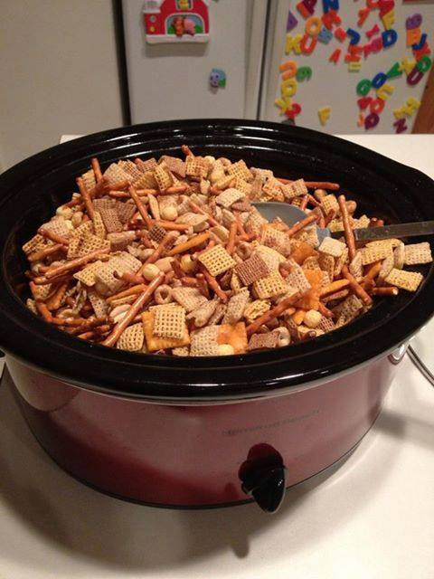

CROCKPOT CHEX MIX
Fill crock pot with your favorite cereal, pretzels and nuts. Melt 1/4 cup butter, add 4 tsp worchestershire sauce, 1 tsp salt, 1 tsp garlic powders, 1/2 tsp onion powder, 1/4 tsp sugar, dissolve & stir. Pour over cereal & mix. Cook on LOW for 2.5 hours, open lid & stir every 30 minutes. Enjoy!

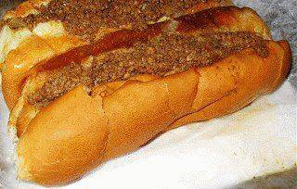
~CONEY SAUCE for HOT DOGS~
1-1/4 Lbs.- Hamburger
1- Large Onion
1/2- C. Sugar
1/2- C. Chili Powder
1/2- C. Ketchup
1-1/2- C. Water
1). Chop Onion
2). Mix Hamburger & Onion in skillet
3). Brown Hamburger & Onion until Hamburger is done.
4). Drain.
5). Put mixture back in skillet and add remaining ingredients.
6). Simmer 1 hour, stirring occasionally.
7). Serve on Hot Dogs.
Can be frozen until ready to use.

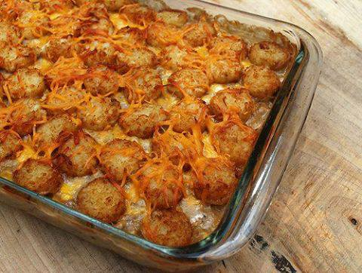
Cowboy Casserole -
1 1/2 pounds ground beef (I used 80/20)
1 medium onion, chopped
3 cloves garlic, chopped
1 can (15.25oz) whole kernel corn, drained
1 can condensed cream of mushroom soup
2 cups cheddar cheese, shredded
1/2 cup milk
4 tablespoons sour cream
1 bag (30 oz) frozen tater tots (I used Ore-Ida Crispy Crowns)
Before I got ready to make this casserole, I let the Crispy Crowns sit on the counter to defrost for an hour or so. The original recipe used still frozen tater tots, but I felt they wouldn't cook as well if they were still frozen solid.
In a large skillet cook the onion until tender and translucent. Add the chopped garlic and cook for 1 minute more. Add the beef and cook over medium heat until no longer pink. Drain the mixture and place into a large bowl and set aside.
In a small bowl combine the soup, milk and sour cream. Whisk until smooth. Add to hamburger mixture and stir to combine. Add corn and 1 cup of cheddar cheese. Gently mix to combine.
Grease a 9x13 inch baking dish. Layer half of the Crispy Crowns on the bottom, pour the hamburger mixture over the top and then layer with the other half of the Crispy Crowns. Sprinkle with remaining 1/2 cup cheese and bake at 350 for 25 - 30 minutes, or until golden brown and crunchy.
*Note - The second time I made this I prepared it the night before and stuck it in the fridge overnight. I took it out about an hour before I wanted to bake it, just so it could come to room temperature a bit. I think it was even better than the first one!

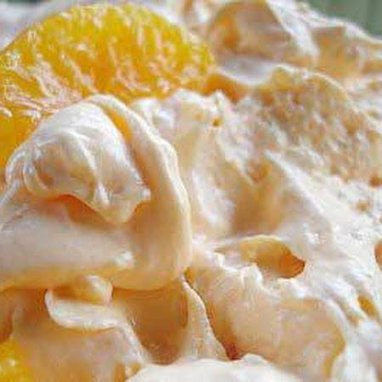
DREAMSICLE SALAD (SUGAR FREE)
A everyday go to dessert with NO guilt!
Try strawberry jello with strawberries and other favors with seasonal fruit.
Ingredients
1 - .3 ozs pkg. sugar free orange jello
1 - 3 ozs. pkg. sugar free instant vanilla pudding
1 - 10 ozs. can mandarin oranges, drained
1 - 8 ozs. tub fat free frozen whipped topping, thawed
Directions
Dissolve jello in 1 c. boiling water. Add 1/2 c. cold water; let /set in fridge for 20 minutes. With mixer or whisk, add dry vanilla pudding mix and beat until smooth. Fold in oranges and whipped topping (by hand). Refrigerate.

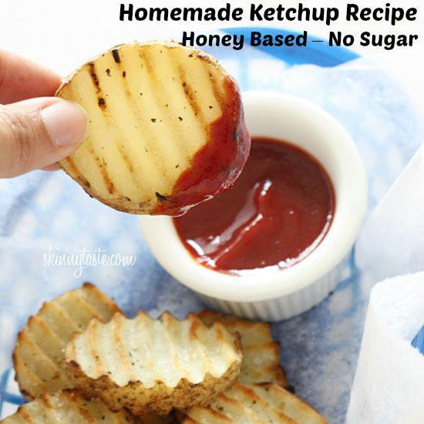
Homemade Honey-Based Ketchup!
Ingredients:
6 oz can tomato paste
1/4 cup honey (or agave)
1/2 cup white vinegar
1/4 cup water
3/4 tsp salt
1/4 tsp onion powder
1/8 tsp garlic powder
Directions:
Combine all the ingredients in a medium saucepan over medium heat; whisk until smooth.
When it comes to a boil, reduce heat to low and simmer for 20 minutes, stirring often.
Remove from heat and cover until cool. Chill and store refrigerated in a covered container.

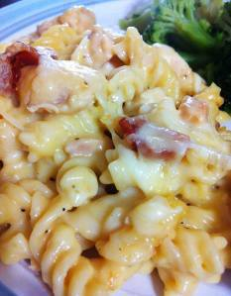
CRAZY GOOD CASSEROLE
4-5 boneless, skinless chicken breasts
6 strips of quality bacon – cooked and crumbled
2 cans cream of chicken soup
2 cups shredded Monterrey Jack cheese
1 box (16 ounces) dried spiral pasta
1 tablespoon garlic powder
Salt & pepper to taste
Cook & crumble bacon. While bacon is cooking, cut chicken into bite-sized chunks. Set cooked bacon aside for later use. In the same pan, cook chicken in bacon drippings. Add garlic powder & salt & pepper to taste.
While chicken is cooking, prepare pasta according to directions. Spray a 9 xc 13 inch baking pan with non-stick cooking spray. Preheat oven to 400 degrees.
Drain pasta, return to pot. Add chicken, both cans of cream of chicken soup, 1 cup of Monterrey Jack cheese ~ stir to mix well. Pour into prepared baking dish. Top with crumbled bacon. Top with remaining Monterrey Jack cheese. Back at 400 for about 20 minutes, just until cheese is melted and beginning to brown on top.

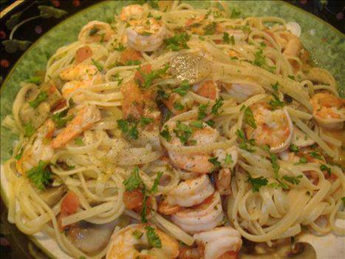
Italian Shrimp Fettuccine -
INGREDIENTS:
2 tablespoons olive oil
1 cup fresh mushrooms, sliced
4 green onions, sliced
1 tablespoon garlic, minced
2 (14 1/2 ounce) cans diced tomatoes, undrained
1/2 cup fresh parsley, chopped
1/4 cup white wine
8 ounces fettuccine
1/2 lb. raw shrimp, peeled and deveined
2 tablespoons lemon juice.
DIRECTIONS: Heat the oil in a large skillet over medium heat until hot. Add the mushrooms, green onions and garlic. Sauté for 1-2 minutes or until green onions start to soften. Stir in the tomatoes, parsley and wine. Bring to a boil. Reduce heat and simmer for 20 minutes to allow the flavors to blend.
Meanwhile, cook the fettuccine in a large pot of boiling salted water according to package directions and drain. Add the shrimp and lemon juice to tomato mixture. Cook for 1-2 minutes or until the shrimp turn pink. Serve over the cooked fettuccine.

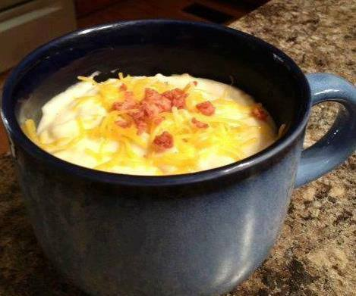
Crockpot Potato Soup for Weight Watchers
Here's a recipe that is only 2 Points per cup, easy, and very filling!
Makes 8-10 cup servings
WW Pts+: 3.5 per cup
INGREDIENTS:
1 26-30 ounce bag frozen hash browns (plain)
2 14 ounce cans non-fat chicken broth
1 10-3/4 ounce can 98% fat-free cream of chicken soup
1/4 cup chopped onion
1/4 tsp pepper
1 8 ounce pkg. low-fat (1/3 less fat) cream cheese
1 cup fat free milk
DIRECTIONS: Add first 5 ingredients to crockpot and cook on high for an hour. Stir and then turn to low for another hour. Add cream cheese and cook another 1/2 hour or until cheese can be stirred into mixture. Add milk and cook 10-15 minutes longer.
OPTIONAL: Garnish with chopped green onion and bacon bits. (Add 1 point for garnish).
VARIATION: Use frozen Country potatoes or Potatoes O'Brien in place of the hash browns.

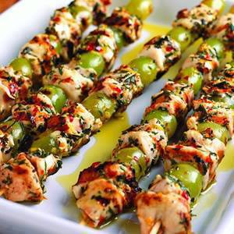
Mediterranean Grilled Chicken and Grape Skewers
Ingredients
1/4 cup extra virgin olive oil
2 cloves garlic, fresh minced
1/2 teaspoon red chili flakes, crushed
1 tablespoon oregano, fresh minced
1 tablespoon rosemary, fresh minced
1 teaspoon lemon zest
1 pound chicken breast, boneless and skinless
1-3/4 cups California green seedless grapes, picked from stem & rinsed
1/2 teaspoon salt
2 tablespoons extra virgin olive oil
1 tablespoon lemon juice, fresh
PREPARATION:
In a small bowl, combine olive oil, garlic, chili flakes, oregano, rosemary and lemon zest. Whisk together this marinade.
Cut chicken into 3/4-inch cubes. Alternate chicken and grapes and thread onto 12 skewers. Place skewers into a baking dish or pan large enough to hold them. Pour marinade over skewers, coating each one. Marinade for 4-24 hours. Remove skewers from marinade and let excess oil drip off. Season with salt. Grill until chicken is cooked through, about 3-5 minutes on each side. Arrange on serving platter and drizzle with additional olive oil and lemon juice.

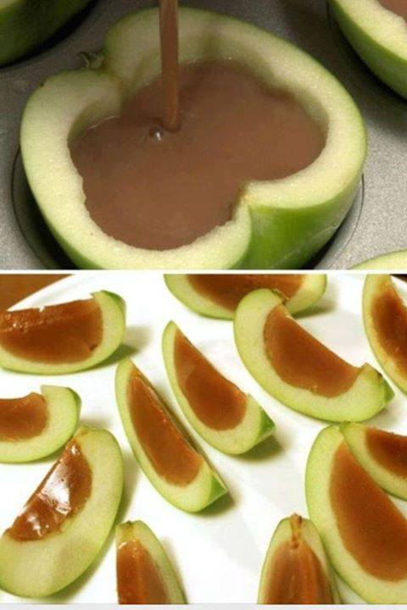
Do u love caramel apples but hate trying to eat them? Try it this way! (found this and could not keep it to myself!! I can't wait to try it!) Hollow out your apples, (u can balance the apple halves in a muffin pan) fill will melted caramel, let the caramel harden and cut into slices! yummy!

~BUFFALO CHICKEN MEATBALLS~
1 pound lean ground chicken
1 egg
1/2 cup panko breadcrumbs
1 carrot
1 stalk celery
2 green onions
1/2 teaspoon garlic powder
1/4 teaspoon sea salt
1 ounce crumbled blue cheese
1/2 cup Frank's Hot Sauce (or your favorite), divided
1 tablespoon butter or margarine
Step by step
Preheat the oven to 350F.
Line a cookie sheet with foil and coat with nonstick spray.
Cut the celery, carrot and green onion into large chunks and throw into a food processor.
Pulse to chop into small bits.
In a large bowl, combine the vegetable mixture, chicken, egg, breadcrumbs, garlic powder, salt, 1/2 the hot sauce and the blue cheese.
Gently fold together, but do not over mix.
Form the mixture into small meatballs - you should get about 28 small meatballs.
Place the meatballs on the cookie sheet.
Bake for 20 minutes.
While the meatballs are baking, put the rest of the hot sauce and the butter into a microwave safe dish.
Microwave about 30 seconds, until butter melts.
Stir well to combine.
Remove the meatballs from the oven and allow to cool for a few minutes.
Place the meatballs onto a serving dish and drizzle with butter/hot sauce mixture.
Enjoy!

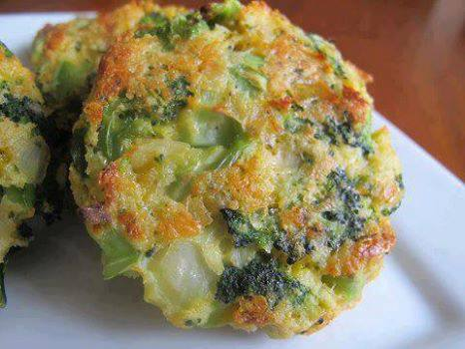
Baked Cheese & Broccoli Patties
yield: 8 broccoli patties
INGREDIENTS:
2 teaspoons vegetable oil
2 cloves garlic - minced
1/2 onion - chopped
1 (12 ounce) bag frozen broccoli - defrosted
3/4 cup panko breadcrumbs
1/2 cup sharp cheddar cheese
1/3 cup parmesan cheese
2 eggs - beaten
salt/pepper
INSTRUCTIONS:
preheat the oven to 400 degrees. Lightly grease a baking sheet lined with aluminum foil.
Heat the oil in a small pan over medium heat, add in the garlic and onions. Season with salt/pepper to taste. Sauté until onions are garlic are tender, set aside to cool.
Add the broccoli to a kitchen towel. Wrap the towel around the broccoli and squeeze out the extra moisture. Pour the drained broccoli into a large bowl, add the onion and garlic and mix gently.
To the same bowl, add the panko, the cheeses, eggs, and salt/pepper to taste.
Mix together and form into patties, place on the prepared baking sheet.
Bake in the preheated oven for 15 minutes. Flip and bake for another 15 minutes or until browned and crispy.

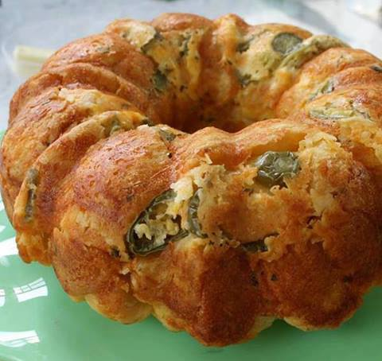
Fiesta Bubble Bread
For those of you not into sweets, yet enjoying the "Spice of Life", try this one!!! NOTE: you can mix & match ingredients... I've even added Jimmy Dean Sausage, cooked & crumbled... OMWORD!!!! (It's a very forgiving recipe.) Enjoy!!! --CG
1/2 c. butter, melted
1-1/2 c. shredded Mexican-blend cheese
1/4 c. shredded mozzarella cheese
10-oz. jar sliced jalapeño peppers, drained
1 t. dried parsley
2-12-oz. tubes refrigerated biscuits, cut into quarters
In a large bowl, combine butter, cheeses, pepper slices and parsley; add biscuits and toss to coat. Transfer to an ungreased Bundt pan. Bake at 350 degrees for 30 minutes, or until golden. Invert onto a serving plate; serve warm.

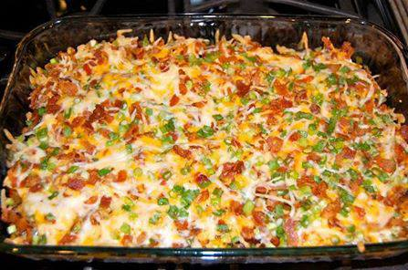
Loaded Baked Potato & Chicken Casserole
Ingredients
2 lbs. chicken breast
8 potatoes
1/3 cup Olive Oil
1 1/2 tsp salt
1 TBS fresh Ground Pepper
1 TBS Paprika
2 TBS Garlic Powder
6 TBS Hot Sauce
{Toppings}
2 cups Shredded Cheese
1 cup crumbled Bacon
1 cup diced Green Onion
Instructions
Preheat oven 500F
In a large bowl mix Olive Oil, Salt, Pepper, Paprika, Garlic Powder & Hot Sauce
Cube the potatoes & add to the bowl
Coat a 9x13 dish with cooking spray
Add potatoes, allow for excess sauce in the bowl
Bake the potatoes for 45 minutes, stir every 15 minutes
Cube the chicken & add it to the bowl with the left over sauce
Mix together cheese, bacon & green onion in a small separate bowl
Once potatoes are done, add the uncooked marinated chicken
Then layer the toppings over the chicken
Bake for 15 minutes or until the chicken is cooked

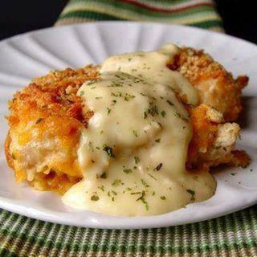
Crispy Cheddar Chicken
2 lbs chicken tenders or 4 large chicken breasts
2 sleeves Ritz crackers
1/4 teaspoons salt
1/8 teaspoon pepper
1/2 cup whole milk
3 cups cheddar cheese, grated
1 teaspoon dried parsley
Sauce:
1 10 ounce can cream of chicken soup
2 tablespoon sour cream
2 tablespoon butter
Crush crackers. If using chicken breasts and not tenders, cut each chicken breast into 3 large pieces. Pour the milk, cheese and cracker crumbs into 3 separate small pans. Toss the salt and pepper into the cracker crumbs and stir the mixture around to combine. Dip each piece of chicken into the milk and then the cheese. Press the cheese into the chicken with your fingers. Then press the cheesy coated chicken into the cracker crumbs and press it in.
Spray a 9×13 pan with cooking spray and lay the chicken inside the pan. Sprinkle the dried parsley over the chicken. Cover the pan with tin foil and bake at 400 degrees for 35 minutes. Remove the tin foil, bake for an additional 10-15 minutes, or until the edges of the chicken are golden brown and crispy.
In a medium sized sauce pan combine the cream of chicken soup, sour cream and butter with a whisk. Stir it over medium high heat until the sauce is nice and hot. Serve over the chicken.

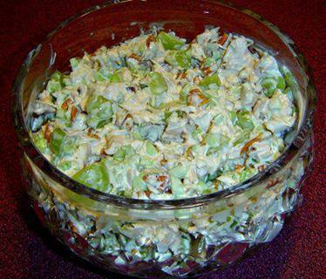
Pecan Chicken Salad
4 cups chicken breast chopped or 2-15oz. cans
1 1/2 cups sliced seedless grapes (red or white)
3/4 cup chopped celery (this is a little too much for me, I'd reduce to 1/2 cup or less)
1 Tbs sugar
1 Tbs Worcestershire sauce
1 Tbs lemon juice
3/4 cup pecans
1 cup mayonnaise
Mix all ingredients and stir together, enjoy!

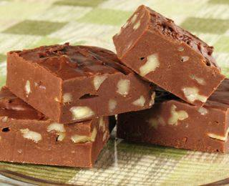
Diabetic Friendly
SUGAR FREE FUDGE
Ingredients
2-8 OZ. PKGS REDUCED FAT CREAM CHEESE
2-1 OZ SQUARES. UNSWEETENED CHOCOLATE-MELTED AND COOLED
SUGAR SUBSTITUTE EQUAL TO 1 CUP SUGAR
1 TEASPOON VANILLA
1/2 CUP PECANS, CHOPPED
DIRECTIONS: In a small bowl, beat the cream cheese, chocolate, sweetener and vanilla until smooth. Stir in pecans. Pour into an 8-inch square pan lined with foil. Cover & refrigerate overnight. Cut into 16 squares. Serve chilled. Yields 16 servings. Serving size: 1 piece
Calories 17
Total Fat 14g
Saturated Fat 0g
Sodium 84mg
Protein 3g
Carbohydrate 5g
Cholesterol 31mg
Fiber 0g
Dietary Exchange 3 Fa

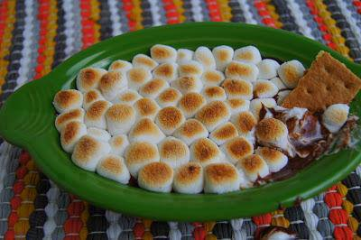
S'MORES DIP
INGREDIENTS:
1 cup of milk chocolate chips
2 Tbsp of milk
1-1/4 cups mini marshmallows
Graham crackers for dipping
DIRECTIONS: In a medium sauce pan, add chocolate chips and 1 cup of your marshmallows. Mix continuously over medium heat until melted and smooth. Using a rubber spatula, scrape chocolate mixture into a small casserole dish. Top with remaining marshmallows. Place dish under your oven broiler for approximately 60 seconds or until the top has started to brown. Dip your graham crackers and enjoy!

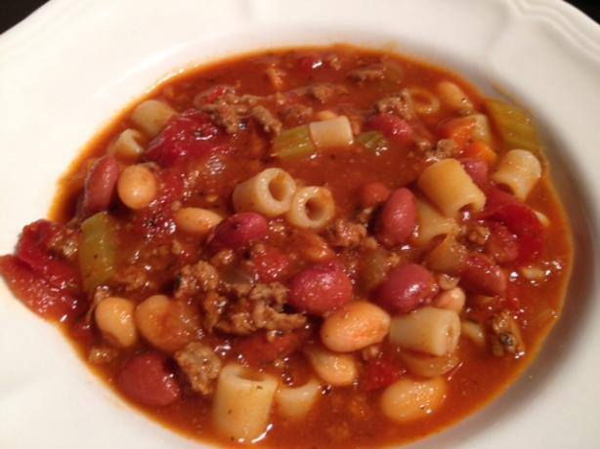
Pasta Fagioli slow cooker crock pot version...
just like Olive Garden
2 lbs ground beef
1 onion, chopped
3 carrots, chopped
4 stalks celery, chopped
2 (28 ounce) cans diced tomatoes, undrained
1 (16 ounce) can red kidney beans, drained
1 (16 ounce) can white kidney beans, drained
3 (10 ounce) cans beef stock
3 teaspoons oregano
2 teaspoons pepper
5 teaspoons parsley
1 teaspoon Tabasco sauce (optional)
1 (20 ounce) jar spaghetti sauce
8 ounces pasta
Directions:
1. Brown beef in a skillet.
2. Drain fat from beef and add to crock pot with everything except pasta.
3. Cook on low 7-8 hours or high 4-5 hours.
4. During last 30 min on high or 1 hour on low, add pasta.

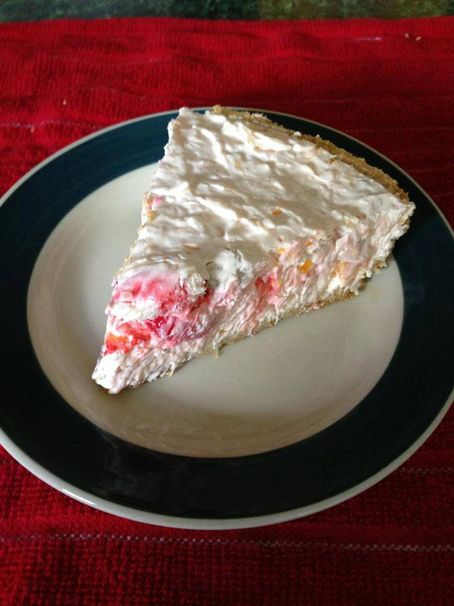
Million Dollar Pie
I make this a lot an have for years. Everyone LOVES it!!
2 Graham Cracker pie crusts
1 15oz can of Crushed pineapple (drained well)
1 9oz tub of Cool Whip THAWED
1 can Sweetened Condensed Milk
1/4 cup Lemon Juice
1/2 tsp Vanilla extract
You can add Maraschino cherries, Coconut, walnuts and Mandarin oranges. The amount of each depends on your taste.
Mix everything EXCEPT the Cool whip together in a large bowl, mix well then add the Cool whip last.
Divide the mixture between the 2 crusts, chill for at least about 2 hours or overnight.

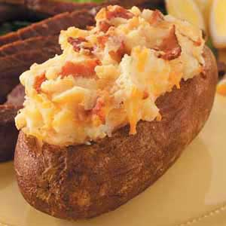
Twice Baked Cheddar Potatoes

- 6 large baking potatoes
- 8 tablespoons butter, divided
- 1/4 pound sliced bacon, diced
- 1 medium onion, finely chopped
- 1/2 cup 2% milk
- 1 egg
- 1/2 teaspoon salt
- 1/8 teaspoon white pepper
- 1 cup (4 ounces) shredded cheddar cheese

Directions
- Preheat oven to 400°. Scrub and pierce potatoes; rub each with 1 teaspoon butter. Place on a baking sheet. Bake 45-50 minutes or until tender.
- Meanwhile, in a small skillet, cook bacon over medium heat until crisp. Remove to paper towels; drain, reserving 1 tablespoon drippings. In drippings, saute onion until tender; set aside.
- When potatoes are cool enough to handle, cut a thin slice off the top of each and discard. Scoop out pulp, leaving a thin shell. In a small bowl, mash pulp with remaining butter. Stir in milk, egg, salt and pepper. Stir in the cheese, bacon and onion.
- Spoon into the potato shells. Place on a baking sheet. Bake at 400° 15-20 minutes or until heated through. Yield: 6 servings.

Variations: Twice Baked Potatoes can have multitudes of variations.. some of my favorites are to add Broccolli to the potato, either sprinkle on top, or whip into the potato.

Instead of Cheddar cheese, Use Philadelphia Cream Chees.. Oh why not.. go ahead and top it with cheddar cheese.. Adds lots of nice color.

Add a package of Ranch Dressing Mix and have a Ranch style Potato
Use Ham instead of Bacon
Use Sweet Potatoes instead… Awesome or Mix them…

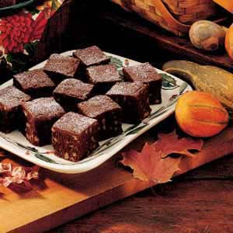
Fudge Brownies

Ingredients

1 cup butter
6 ounces unsweetened chocolate, chopped
4 eggs
2 cups sugar
1 teaspoon vanilla extract
1/2 teaspoon salt
1 cup all-purpose flour
2 cups chopped walnuts
Confectioners' sugar, optional

Directions
In a small saucepan, melt butter and chocolate over low heat; cool for 10 minutes. In a large bowl, beat the eggs, sugar, vanilla and salt. Stir in the chocolate mixture. Add flour and nuts; mix well.
Pour into a greased 11-in. x 7-in. baking dish. Bake at 325° for 45-50 minutes or until a toothpick inserted near the center comes out with moist crumbs. Cool on a wire rack. Dust with confectioners' sugar if desired. Cut into bars. Yield: 16 servings.

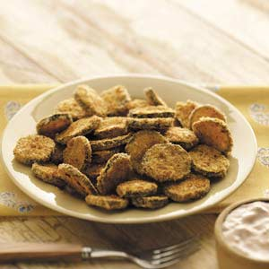
Zucchini Fritters

Prep: 20 min. Bake: 20 min. Yield: 10 Servings

Ingredients

1/4 cup buttermilk
1/4 cup egg substitute
1/2 cup panko (Japanese) bread crumbs
1/2 cup seasoned bread crumbs
1/4 cup grated Parmesan cheese
1-1/2 teaspoons taco seasoning
1/4 teaspoon garlic salt
3 medium zucchini, cut into 1/4-inch slices
1/4 cup fat-free sour cream
1/4 cup fat-free ranch salad dressing
1/4 cup salsa

Directions
In a shallow bowl, combine buttermilk and egg substitute. In another shallow bowl, combine the bread crumbs, cheese, taco seasoning and garlic salt. Dip zucchini in buttermilk mixture, then bread crumb mixture.
Place on baking sheets coated with cooking spray. Bake at 400° for 20-25 minutes or until golden brown, turning once.
In a small bowl, combine the sour cream, ranch dressing and salsa. Serve with zucchini. Yield: 10 servings (3/4 cup sauce).

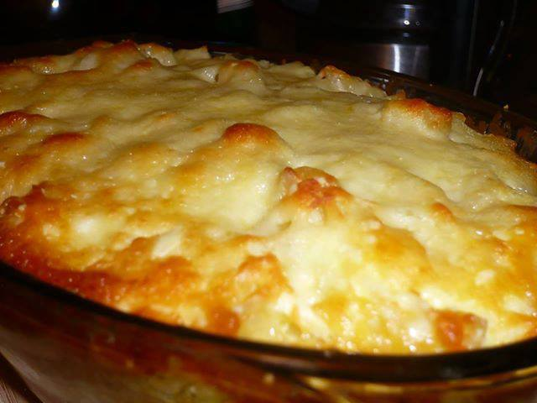
MAMA'S CREAMY BAKED MACARONI AND CHEESE
Makes 8 -10 servings.
JUST LIKE MAMA MADE!!!!
16 ounces elbow macaroni (about 3 cups)
3 tablespoons butter or margarine
1 ½ cups milk, divided
2 large eggs, lightly beaten
1 lb (16-ounces) cubed (1/2 inch size) Velveeta cheese
8 ounce shredded Kraft Mild Cheddar Cheese (about 2 cups), divided
8 ounce shredded Kraft Monterrey Jack Cheese
1 teaspoon salt
1 teaspoon freshly ground black pepper
Heat oven to 375 degrees F.
1. Cook macaroni in a large pot of salted boiling water until tender but not mushy, about 8-10 minutes. Drain well and pour into a large mixing bowl.
2. Melt on low the Velvetta Cheese and ¾ cup milk until melted (stir often)
3. Pour Melted Cheese Sauce over Pasta and Stir. Add in butter, ¾ cups milk, eggs, 1 cup shredded cheeses, salt and pepper. Mix well and transfer to a 2 quart baking dish. Pour the remaining cheese on top.
Bake until top crust is golden brown and casserole is bubbling, about 25 minutes. Serve hot .

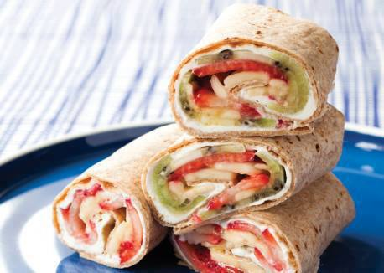
CHEESECAKE FRUIT WRAPS!!!
Serves 6
Prep Time: 30 minutes or fewer
When fresh fruit and cream cheese get rolled together in a tortilla, the result tastes a lot like cheesecake. Use whatever fruit kids prefer, but don’t skip the bananas, which help hold the wraps together.
1 4-oz. pkg. reduced-fat cream cheese
2 tsp. sugar, optional
4 drops vanilla extract
3 8-inch whole-wheat tortillas
10–12 strawberries, thinly sliced
½ small cantaloupe, thinly sliced, or 3 kiwifruits, peeled and thinly sliced
2 bananas, thinly sliced
1. Mash together cream cheese, sugar (if using), and vanilla extract in bowl with fork until smooth.
2. Spread each tortilla with 2 Tbs. cream cheese mixture, spreading all the way to edges. Scratch square in cream cheese with butter knife or spatula (make biggest possible square you can fit inside tortilla). This will define the filling area.
3. Arrange strawberries and cantaloupe or kiwifruit in single layer inside square. Top with banana slices.
4. Fold up bottom of tortilla along scratched line, and fold in sides along lines. Tightly roll up tortilla, pushing in any filling that slides out. Set seam side down on plate, and press to seal. Freeze 10 minutes to set. Cut in half on bias, and serve.

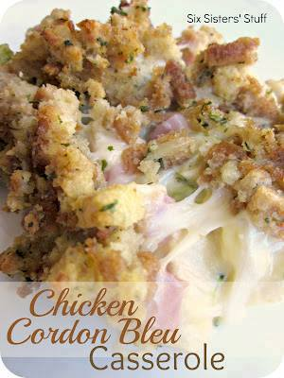
Chicken Cordon Bleu Casserole
Ingredients:
1 (6 oz) pkg. chicken flavored stuffing mix
1 (10 3/4 oz) can condensed cream of chicken soup
1 tablespoon prepared, Dijon mustard
3-4 boneless, skinless chicken breasts, cooked or boiled and cut into bite-size pieces
3 cups fresh broccoli florets
2 cups cooked, chopped ham
6 slices of extra thin Swiss cheese
Directions:
Preheat oven to 375ºF. Prepare stuffing as directed on package. Mix soup and mustard in medium bowl; stir in chicken, broccoli and ham. Spoon into 2-qt. casserole dish sprayed with cooking spray; top with cheese slices and stuffing. Bake 35 to 40 minutes or until heated through.

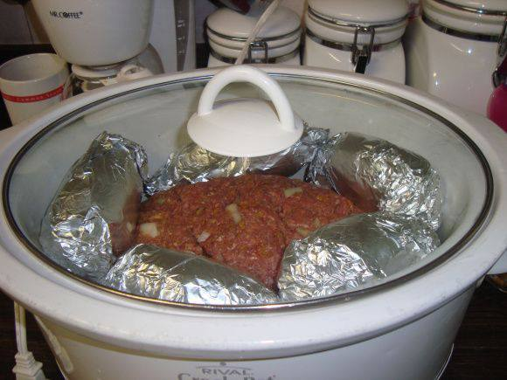
~ Crockpot Meatloaf & Potatoes ~
2.5 pounds of ground turkey (or beef, if you prefer)
1 egg
3/4 cup smashed cornflakes or bread crumbs ( but I prefer corn flakes)
1 envelope of Lipton onion soup mix
1/4 cup Worcestershire sauce
salt, pepper, paprika, garlic salt, Italian seasoning to taste.
Mix the ingredients well and form a “loaf” in the bottom of your crock pot.
Then, wash 5-6 potatoes, prick them with a knife or fork, and wrap them in foil. Place them around the meatloaf. Cook for 8-10 hours on low.

Two Minute Hawaiian Pie
This pie actually does just take a few minutes to prepare
1 can(s) crushed pineapples, undrained (20oz)
1 bx instant vanilla pudding mix (6 serving )
8 oz sour cream
1 9 inch graham cracker crust
1 can(s) (8oz) pineapple slices
8 maraschino cherries
1/2 c sweetened flaked, coconut
1 sm container of cool whip for piping
in a large bowl, combine crushed pineapple with its syrup, dry pudding mix, and sour cream; mix until well combined. Spoon into pie crust and decorate top with pineapple slices and cherries; sprinkle with coconut.
Pipe with Cool Whip if so desired..Cover and chill at least 2 hours before serving.

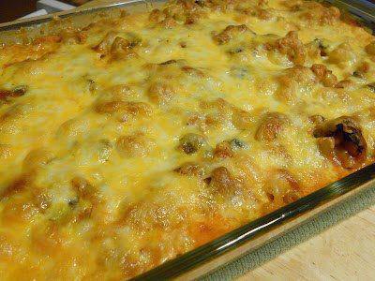
Million Dollar Spaghetti Casserole
Ingredients
1 lb. of Ground Beef
28 oz spaghetti sauce
8 oz of Cream Cheese
1/4 cup of Sour Cream
1/2 lb. of Cottage Cheese
Whole Stick of Butter
1lb pasta such as elbow noodles or rotini
Bag of shredded cheese (I use pizza blend)
optional: sliced mushrooms, diced bell pepper, diced onion
Directions
Preheat oven to 350. Boil the noodles. Mix together the cream cheese, sour cream and cottage cheese in a mixer to thoroughly mixed together. Set aside. If you have chosen to use the bell pepper or onion saute them for 3 minuted then toss in the hamburger meat. Brown hamburger meat in a skillet and drain. Add spaghetti sauce and mix together. Put a few slices of butter in bottom of a 9×13 casserole dish. Then layer half of the noodles in the bottom of the dish. Spread the cheese mixture over this layer. Then add the rest of the noodles on top of this with a few pats of butter.
Now pour the red sauce and meat on top and spread.
Bake for 30 minutes. Remove from oven and spread cheese on top and return to oven for another 15 minutes or until cheese is melted and bubbly.

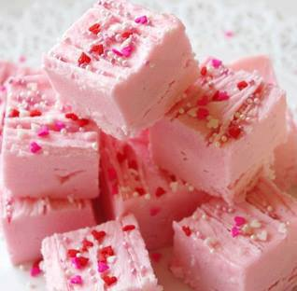
STRAWBERRY FUDGE
INGREDIENTS:
1 16 oz can of strawberry frosting
1 12 oz bag of white chocolate chips
2/3 cup chopped pecans
DIRECTIONS:
Lightly spray an 9×9 pan ( or a 9 x 13 pan for thinner bars ) with cooking spray.
Put white chocolate chips in microwave safe bowl and melt them,( not letting them burn) You could also use a double boiler.
Stir in entire can of strawberry frosting.
Stir in pecans.
Spread into pan and chill in refrigerator for 30 minutes.
Cut into squares and serve...

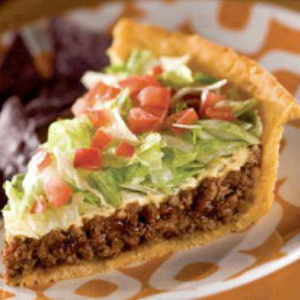
TACO PIE!!!
Ingredients:
1/4 cup butter
2/3 cup milk
1 package Taco Bell seasoning mix
2 1/2 cups mashed potato flakes (you could also use left over mashed potatoes and omit the butter and milk)
1 pound ground beef
1/2 cup chopped onion
1/2 cup salsa
1 cup shredded lettuce
1 medium tomato, chopped
1 cup sharp cheddar cheese, shredded
Sour cream, optional
Directions:
Preheat oven to 350 degrees. In a medium sauce pan, melt butter. Add milk and 2 tablespoon taco seasoning.
Remove from heat and add potato flakes until incorporated. Press mixture into the bottom of a 10-inch pan. Bake for 7-10 minutes until it just BARELY turns golden brown.
In a medium skillet, cook beef and onions until beef is browned and cooked through. Drain. Add Salsa and remaining taco seasoning. Cook until bubbly. Pour into crust. Bake for 15 minutes, or until crust is golden brown. Let cool for 5 minutes.
Top with cheese, lettuce, and tomatoes. Cut and serve with sour cream.

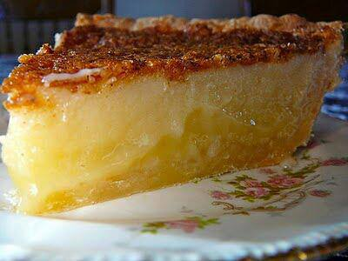
BUTTERMILK PIE

Ingredients
1/2c buttermilk
1 3/4c sugar
2 large eggs
3tbsp flour
pinch of salt
1 stick butter
1tsp vanilla
nutmeg
Preheat oven to 400°. Mix everything together and pour into an unbaked 9" pie shell. Sprinkle the top lightly with nutmeg. Bake 15min. Reduce oven to 350° and bake 45min. Cool to allow filling to set.

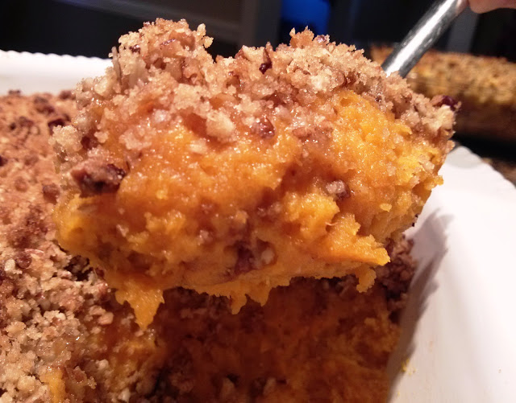
Sweet Potato Praline Casserole

Sweet Potatoes:
4 lbs. sweet potatoes
3/4 to 1 cup sugar
1 teaspoon vanilla
1/2 teaspoon salt
2 eggs, beaten
6 tablespoons butter, melted

Praline Topping:
1/2 cup all-purpose flour
1 cup dark brown sugar
1 heaping cup chopped pecans
1/2 cup butter, melted
Pinch of salt

Arrange sweet potatoes on a baking sheet lined with aluminum foil then pierce each with a fork a few times to vent. Bake at 400 degrees until tender (usually about an hour for large sweet potatoes). Check tenderness by inserting a knife into the thickest potato knife should slide in easily with no resistance. Do not boil the potatoes or use canned ones.

Allow sweet potatoes to cool to room temperature then remove the skins. Add sweet potatoes, sugar, vanilla, salt, eggs and butter to a medium bowl or stand mixer. Mix on medium speed with an electric mixer for 2 minutes or until fluffy. Spoon sweet potato mixture into a 9x9 casserole dish and spread evenly.

To make praline topping, combine flour, brown sugar, pecans, butter and salt in a small bowl and mix until combined. Mixture will be crumbly. Sprinkle praline crumbles evenly over sweet potato mixture. Bake at 350 degrees for 30-35 minutes.

Notes: Start with 3/4 cup of sugar and add more if desired. Some sweet potatoes are much sweeter than others so the amount of sugar that you need can vary. Mix everything up to the eggs and taste it for sweetness. Make it as sweet as you like.

Dark brown sugar yields a richer looking and tasting praline topping. I was out of dark brown sugar and used light as you might be able to tell in the picture.

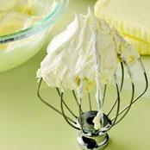
Almost ButterCream Frosting
Ingredients
16 ounce(s) marshmallow cream
1 1/2 cup(s) butter, softened
5 teaspoon(s) fresh lemon juice
1 teaspoon(s) vanilla extract
1/2 cup(s) confectioners' sugar
Directions
Beat the marshmallow cream using an electric mixer set on low.
Add the butter (in 1-inch pieces) and beat until smooth.
Add the lemon juice, vanilla extract, and confectioners' sugar, scraping down the sides of the bowl occasionally, and continue to beat on medium-high until smooth and fluffy.

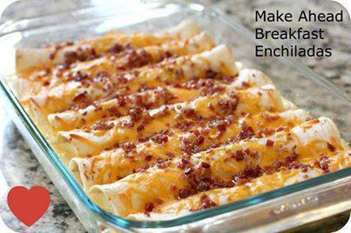
Breakfast Enchiladas!!!
Ingredients:
1lb sausage
2 cups shredded cheddar chesse
8 (8 in) flour tortillas
6 eggs
1 T all-purpose flour
2 cups of half and half
3 oz of real bacon bits
Directions:
Simply cook the sausage in a frying pan. Once cooked stir together the sausage, 1 cup of the cheese, and half of the bacon bits. Place an 1/8th of the mixture in the center of a tortilla and roll them up. Place them seem side down in a greased baking dish. Repeat until all tortillas are used.
In another bowl beat the eggs and flour. Mix in the half-and-half and pour over the tortillas in the pan. You can either cook immediately or cover and put in the refrigerator until morning. Pre-heat oven to 350 degrees. Sprinkle remaining cheese and bacon bits over the tortillas. Cover with foil and bake for 35 min. Uncover dish and bake 10 min longer.

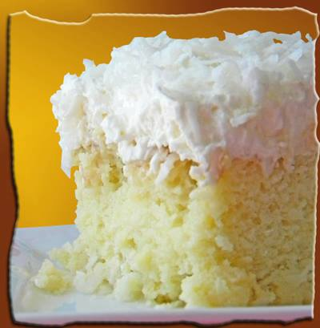
HAWAIIAN WEDDING CAKE
So moist, and as Hawaiian as your creative juices will allow.
2 cups flour
2 cups sugar
2 eggs
2 tsp baking soda
1 cup chopped nuts
1 cup coconut
1 (20 oz.) can crushed pineapple with juice
Mix all ingredients and pour into greased 13 x 9” pan.
Bake at 350 F degrees for 40-45 minutes. Cool.
HAWAIIAN WEDDING CAKE FROSTING:
1 (8 oz.) pkg cream cheese
1 1/2 cup powdered (icing) sugar
1/2 cup butter
2 tsp vanilla
Blend well. Frost cooled cake. Garnish with chopped nuts, coconut or chopped fruit, if desired.
Commentary suggestions:
1 tsp coconut extract in the cake
1/2 tsp coconut extract in the frosting.

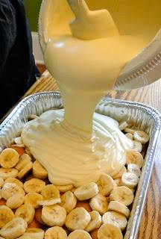
Not Yo Mama's Banana Pudding
Recipe from Paula Deen
2 bags Pepperidge Farm Chessmen Cookies OR 2 bags Vanilla Wafers
6 to 8 bananas, sliced
2 cups milk
1 (5 oz.) box French Vanilla pudding
1 (8 oz.) package cream cheese
1 (14 oz.) can sweetened condensed milk
1 (12 oz.) container frozen whipped topping thawed, or equal amount sweetened whipped cream
Directions
Line the bottom of a 13x9 inch inch dish with 1 bag of cookies and layer bananas on top.
In a bowl, combine the milk and pudding mix and blend well using a handheld electric mixer.
Using another bowl, combine the cream cheese and condensed milk together and mix until smooth.
Fold the whipped topping into the cream cheese mixture.
Add the cream cheese mixture to the pudding mixture and stir until well blended.
Pour the mixture over the cookies and bananas and cover with the remaining cookies.
Refrigerate until ready to serve!

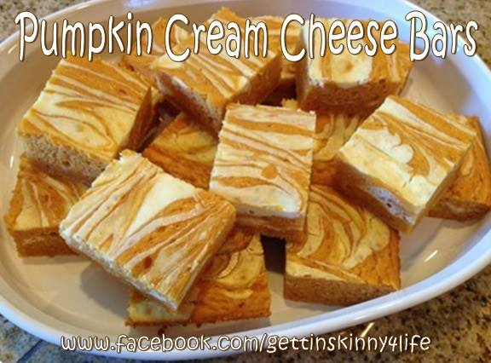
Skinny Pumpkin Cream Cheese Bars
• 1 box angel food cake mix- the 1 step kind
• 1 15oz can Pumpkin
• 3/4 Cup water
• 1/2 teaspoon cinnamon
• 1 8oz pkg. reduced fat cream cheese
• -few tablespoons of water, to be mixed with cream cheese
I let the cream cheese soften on the counter for a while then I added it to my stand mixer & beat it with a couple of tablespoons of water until smooth. I just wanted it to thin out a little bit.
In a separate bowl, mix the cake mix, pumpkin, water, & cinnamon together until it is smooth & well mixed.
In a 9x13 pyrex dish- sprayed with PAM- add HALF of the cake –pumpkin mix. Then smooth it out with a rubber spatula. Drizzle half of the cream cheese over the top of it and take a small spatula to smooth it over the top. Add remaining cake-pumpkin mix & also the remaining cream cheese just making layers. Finally take a butter knife- stick it into the mix and go back & forth over the top of the cake making figure “8’s” - to blend it a bit.
Bake for 35 minutes at 375 degrees OR until a toothpick comes out clean.

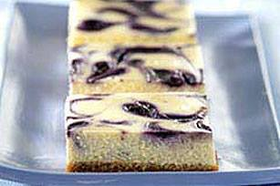
PHILLY® Blueberry Swirl Cheesecake

what you need
1 cup HONEY MAID Graham Cracker Crumbs
1 cup plus 3 Tbsp. sugar, divided
3 Tbsp. butter or margarine, melted
4 pkg. (8 oz. each) PHILADELPHIA Cream Cheese, softened
1 tsp. vanilla
1 cup BREAKSTONE'S or KNUDSEN Sour Cream
4 eggs
2 cups fresh or thawed frozen blueberries

make it

PREHEAT oven to 325°F. Mix crumbs, 3 Tbsp. of the sugar and the butter. Press firmly onto bottom of foil-lined 13x9-inch baking pan. Bake 10 min.

BEAT cream cheese, remaining 1 cup sugar and the vanilla in large bowl with electric mixer on medium speed until well blended. Add sour cream; mix well. Add eggs, one at a time, beating on low speed after each addition just until blended. Pour over crust. Puree the blueberries in a blender or food processor. Gently drop spoonfuls of the pureed blueberries over batter; cut through batter several times with knife for marble effect.

BAKE 45 min. or until center is almost set; cool. Cover and refrigerate at least 4 hours before serving. Store leftover cheesecake in refrigerator.

Kraft kitchens tips SIZE-WISE Enjoy a serving of this rich-and-indulgent treat on special occasions. SUBSTITUTE 1 can (15 oz.) blueberries, well drained, for the 2 cups fresh or frozen blueberries. MAKE IT EASY Instead of using a blender, crush the blueberries in a bowl with a fork. Drain before spooning over the cheesecake batter and swirling to marbleize as directed.

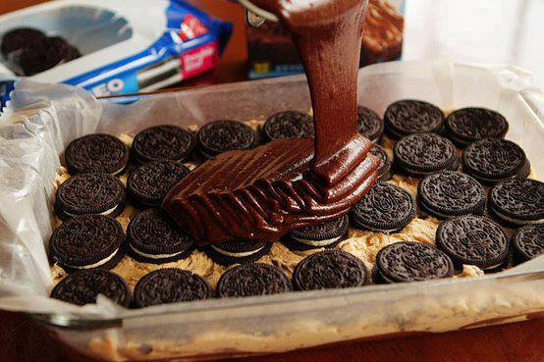
Chocolate Suicide
Chocolate Chip Cookie dough on bottom – (any Recipe)
Oreo cookies arranged in the middle
brownie batter poured over the top.
Bake until brownies are done....top with ice cream and chocolate syrup to go on over the top!!!!!!!!!!
This for Me would be an Eat in Moderation or maybe once every 6 months

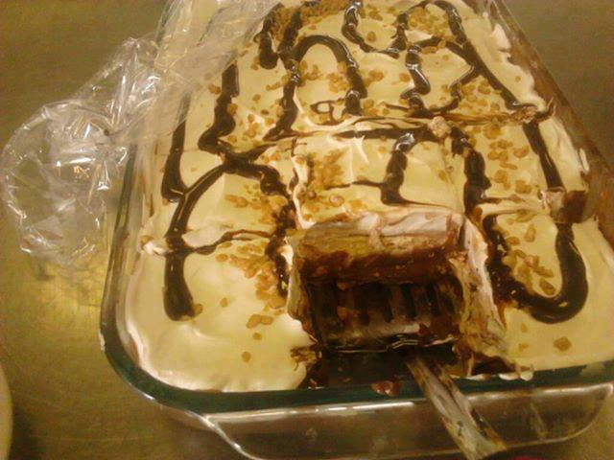
Four Layered Dessert

The first layer is a graham cracker crust:
1 pkg. graham crackers, crushed
1 stick butter
1/2 cup sugar
Second layer
2 pkg. cream cheese
1 cup powdered sugar
1 container cool whip
1 tsp. vanilla
1 cup peanut butter
whipped together and spread on top of crust
Third layer
2 pkg. chocolate pudding mix
2 cups milk
mix and pour over cream cheese filling
Fourth layer
1 container of cool whip....topped with chocolate syrup and sprinkled some heath bits.

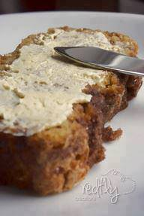
Amish Cinnamon Bread.

No kneading, you just mix it up and bake it
Batter:
1 cup butter, softened
2 cups sugar
2 eggs
2 cups buttermilk or 2 cups milk plus 2 tablespoons vinegar or lemon juice
4 cups flour
2 teaspoons baking soda
Cinnamon/sugar mixture:
2/3 cups sugar
2 teaspoons cinnamon
Cream together butter, 2 cups of sugar, and eggs. Add milk, flour, and baking soda. Put 1/2 of batter (or a little less) into greased loaf pans (1/4 in each pan). Mix in separate bowl the 2/3 c sugar and cinnamon. Sprinkle 3/4 of cinnamon mixture on top of the 1/2 batter in each pan. Add remaining batter to pans; sprinkle with last of cinnamon topping. Swirl with a knife. Bake at 350 degrees for 45-50 min. or until toothpick tester come clean.
Cool in pan for 20 minutes before removing from pan.

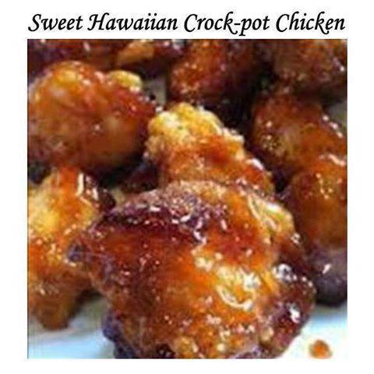
SWEET HAWAIIAN CROCK-POT CHICKEN—
EASY AND YUMMMY!!
2lb. Chicken tenderloin chunks
1 cup pineapple juice
1/2 cup brown sugar
1/3 cup soy sauce
Combine all together, cook on low in Crock-pot 6-8 hours...that's it! Done! Serve with brown rice and you have a complete, easy meal!!

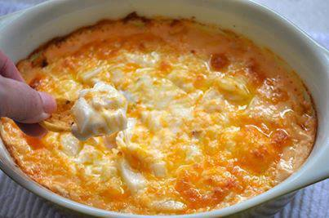
The Cheese Dip That Will Make You Famous!
Try it with jalapeño jack or chipotle seasonings if you like a kick…otherwise, stick to the cheddar.
Ingredients
1 8 oz. package cream cheese
2 cups grated cheddar cheese OR grated jalapeño jack
1 cup mayonnaise
1 small purple onion, diced (you can use chopped green onions as well or omit onions if you don’t like them)
◦Serve with Wheat Thins or Frito’s Scoops for dipping or evenVeggies
Instructions
1. Place all ingredients in a shallow baking dish (a 9″ square pan or round quiche pan will be perfect!)
2. Microwave on high for about 2 minutes or until the ingredients are melted enough to stir together.
3. Stir until combined.
4. Bake at 350 for 20 minutes or until lightly browned.
5. Serve with Wheat Thins or Frito’s Scoops for dipping

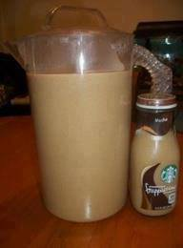
Home Made Frappuccino!!
10 cups brewed coffee
1/2 cup sugar
1/2 cup brown sugar
1/2 cup vanilla creamer (or your choice)
Mix all ingredients together, chill and serve!!

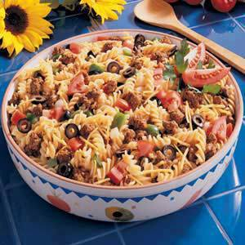
Taco Pasta Salad!!!
Ingredients:
1 package (16 ounces) spiral pasta
1 pound ground beef
3/4 cup water
1 envelope taco seasoning
2 cups (8 ounces) shredded cheddar cheese
1 large green pepper, chopped
1 medium onion, chopped
1 medium tomato, chopped
2 cans (2-1/4 ounces each) sliced ripe olives, drained
1 bottle (16 ounces) Catalina or 16 ounces Western salad dressing
Directions:
Cook pasta according to package directions. Meanwhile, in a skillet, cook beef over medium heat until no longer pink; drain. Add water and taco seasoning; simmer, uncovered for 15 minutes.
Rinse pasta in cold water and drain; place in a large bowl. Add beef mixture, cheese, green pepper, onion, tomato and olives; mix well. Add the dressing and toss to coat.
Cover and refrigerate for at least 1 hour.

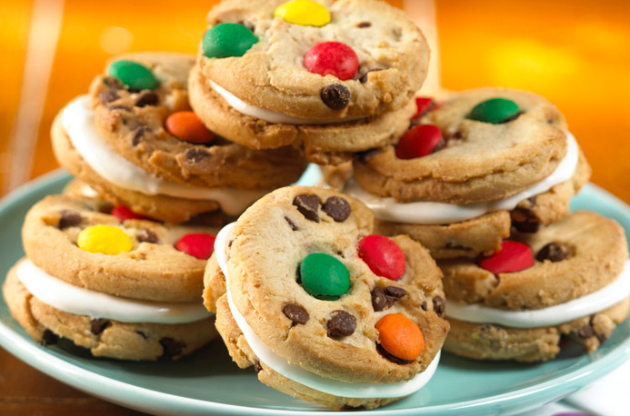
FROZEN WHOOPIE PIES

INGREDIENTS
1 cup marshmallow creme
1/2 cup canned vanilla frosting*
20 Keebler® Chips Deluxe® Rainbow™ Chocolate Chip cookies (divided)
DIRECTIONS
1. In medium bowl fold together marshmallow crème and frosting. Spread about 2 tablespoons on the bottoms of 10 of the KEEBLER CHIPS DELUXE Rainbow Chocolate Chip cookies. 2. Top with the remaining 10 cookies, bottom sides down, gently pressing together to make sandwiches. Individually wrap in plastic wrap. Place on baking sheet. Freeze about 2 hours or until firm. Store in freezer for up to 1 month.

*NOTE: If desired, substitute another 1/2 cup marshmallow crème for the canned frosting.

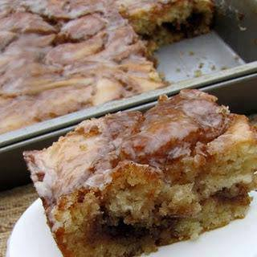
CINNAMON ROLL CAKE
Cake:
3 c. flour
1/4 tsp.salt
1 c. sugar
4 tsp. baking powder
1 1/2 c. milk
2 eggs
2 tsp. vanilla
1/2 c. butter, melted
Topping:
1 c. butter, softened
1 c. brown sugar
2 Tbsp. flour
1 Tbsp. cinnamon
Directions:
Mix everything together except for the butter. Slowly stir in the melted butter and pour into a greased 9x13 pan. For the topping, mix all the ingredients together until well combined. Drop evenly over the batter and swirl with a knife. Bake at 350 for 28-32 minutes.
Glaze:
2 c. powdered sugar
5 Tbsp. milk
1 tsp. vanilla
While warm drizzle the glaze over the cake.

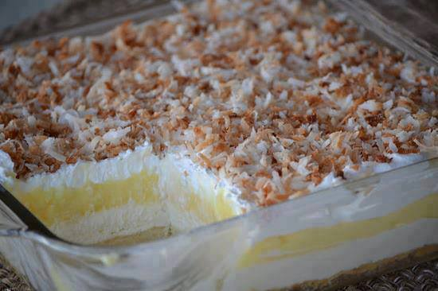
Princess Pie (Coconut Cream Pie)
crust:
1 cup flour
1/2 cup butter, melted
2 Tbs sugar
1/2 cup chopped pecans - optional
Mix and pat in an 8x8 inch pan, bake at 350 degrees for 15-20 minutes, until just beginning to turn golden. Do not over bake.
Layer two:
8 ounces cream cheese, room temperature
1 cup powdered sugar
1 cup whipped topping
Beat together sugar and cream cheese. Fold in whipped topping. Spread on cooled crust.
Layer three:
1 small package coconut cream instant pudding
1 1/2 cups whole milk (any milk will do, but whole milk makes pudding so much tastier)
Mix until thickened. Spread over cream cheese mixture.
Top with remaining tub of whipped topping.
Toast 1 cup coconut. Sprinkle evenly on dessert. Refrigerate.

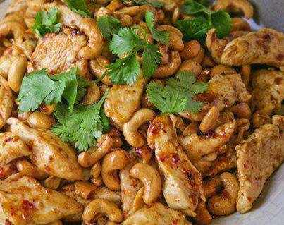
Crockpot Cashew Chicken..
Ingredients:
2 lbs boneless, skinless chicken thigh tenders or chicken breast tenders
1/4 cup all purpose flour
1/2 tsp black pepper
1 Tbsp canola oil
1/4 cup soy sauce
2 Tbsp rice wine vinegar
2 Tbsp ketchup
1 Tbsp brown sugar
1 garlic clove, minced
1/2 tsp grated fresh ginger
1/4 tsp red pepper flakes
1/2 cup cashews ( I love cashews so I would add more )
Directions:
Combine flour and pepper in large Ziploc bag. Add chicken. Shake to coat with flour mixture. Heat oil in skillet over medium-high heat. Brown chicken about 2 minutes on each side. Place chicken in slow cooker. Combine soy sauce, vinegar, ketchup, sugar, garlic, ginger, and pepper flakes in small bowl; pour over chicken. Cook on LOW for 3 to 4 hours. Add cashews and stir. Serve over rice. Makes 4-6 servings.
If you like the sauce and want to have some to pour over the chicken and the rice, double the sauce ingredients...

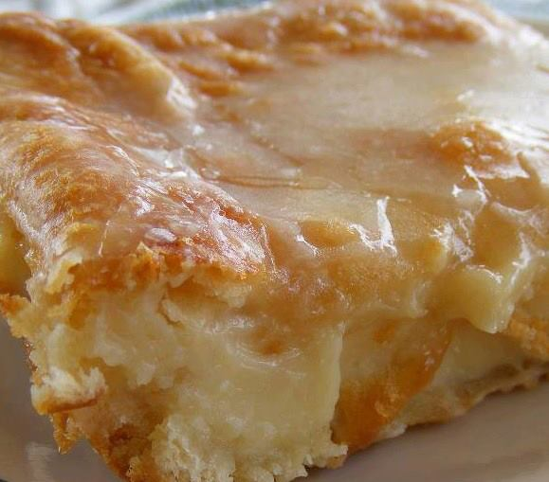
Breakfast Cheese Danish
2 cans ready to use refrigerated crescent rolls
2 (8-ounce each) packages cream cheese
1 cup sugar
1 teaspoon vanilla extract
1 egg
1 egg white
Glaze:
1/2 cup powdered sugar
2 Tablespoons milk
1/2 teaspoon vanilla extract
Preheat oven to 350* degrees and grease a 13X9-inch baking pan. Lay a pack of crescent rolls in the pan and pinch the openings together. Beat the cream cheese, sugar, vanilla, and egg together until smooth. Spread the mixture over the crescent rolls evenly and then lay the second pack of crescent rolls on top of the cheese mixture and brush with egg white. Bake for 35-45

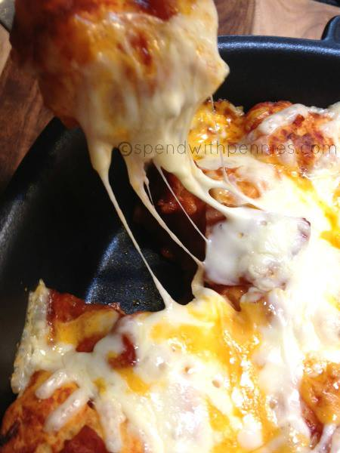
EASY PIZZA BUBBLE BREAD

Ingredients

1 roll of biscuit dough
1 cup pizza sauce
2 cups cheese (I used 1 1/2 cups mozzarella and 1/2 cup cheddar)
Toppings as desired
Instructions

Preheat oven to 375 degrees.
Cut each biscuit into 4 pieces using kitchen scissors or a knife.
In a large bowl, toss biscuit pieces, pizza sauce, toppings and 1/2 cup of cheese.
Spoon biscuit pieces into a well greased 9x9 pan.
Bake for 15-20 minutes or until lightly browned and centre seems cooked.
Top with remaining cheese and bake an additional 5 minutes or until cheese is melted and bubbly.
Serve warm.

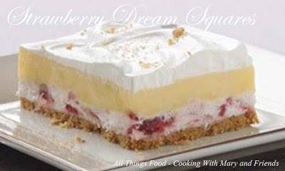
STRAWBERRY DREAM SQUARES

12 HONEY MAID Honey Grahams, finely crushed (about 2 cups)
1/3 cup Butter or margarine, melted
1 pkg. (8 oz.) PHILADELPHIA Cream Cheese, softened
1/4 cup Sugar
1 cup drained mashed thawed frozen strawberries
3 cups thawed COOL WHIP Whipped Topping, divided
2 pkg. (3.4 oz. each) JELL-O Vanilla Flavor Instant Pudding
3-1/2 cups cold milk
Method
MIX graham crumbs and butter. Reserve 2 Tbsp. crumb mixture; press remaining onto bottom of 13×9-inch pan. Refrigerate while preparing filling.
MIX cream cheese and sugar until well blended. Stir in strawberries. Gently stir in 2 cups COOL WHIP; spread over crust.
BEAT pudding mixes and milk with whisk 2 min. Pour over cream cheese filling.
Refrigerate 1 hour; top with remaining COOL WHIP and reserved crumb mixture. Refrigerate 4 hours.

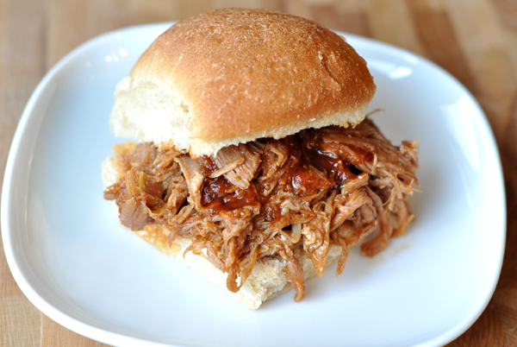
Slow Cooker BBQ Pulled Pork Sandwiches
INGREDIENTS
- 3 to 4 pounds boneless pork shoulder (I’ve also used boneless pork loin – not tenderloin – but pork loin with good results)
- 1/4 teaspoon fresh ground pepper
- 1/4 teaspoon salt
- 2 cups water
- 1 tablespoon hickory flavored liquid smoke
- 2 cups barbecue sauce
DIRECTIONS
- Rinse the pork shoulder and pat dry. Rub salt and pepper over the pork and place in a slow cooker. Add water and liquid smoke. Cook on low setting for 8 to 10 hours, until the pork is very tender.
- Remove the pork from the slow cooker and discard the remaining liquid. Shred the pork using a couple of forks. Place the meat back in the slow cooker along with the barbecue sauce and continue to cook for another 20-30 minutes until the pork is hot again. Serve on buns with extra barbecue sauce.

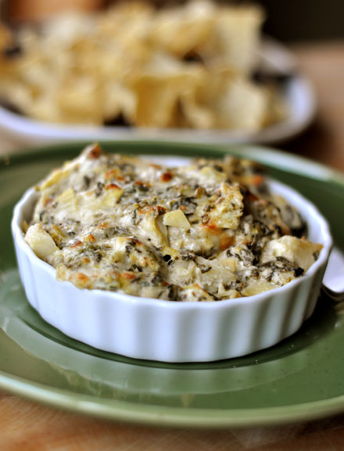
The Best Spinach Artichoke Dip
YIELD: MAKES A 9X13-INCH DISH OF DIP
INGREDIENTS
- 1 1/2 cups whipping cream
- 2 tablespoons flour
- 1/2 teaspoon garlic powder
- 1 teaspoon salt
- 1/2 teaspoon black pepper
- 8 ounces cream cheese, light or regular, softened
- 16 ounces frozen, chopped spinach, defrosted and squeezed dry
- 2 (15-ounce) cans artichoke hearts, drained
- 1 teaspoon hot sauce (like Tapatio brand)
- 1 cup freshly grated Parmesan cheese
- 1 cup freshly grated mozzarella cheese
DIRECTIONS
- Preheat the oven to 350 degrees. Lightly grease a 9X13-inch or similar sized baking dish.
- In a large microwave-safe bowl, whisk together the cream, flour, garlic powder, salt and pepper. Microwave the mixture in 1-minute intervals, whisking fully after each minute, until the mixture is thickened, about 4-5 minutes.
- Stir in the remaining ingredients until well combined. Spread the dip into the prepared pan. Bake for 25-30 minutes until bubbling and golden on top. Serve warm with bread or tortilla chips.

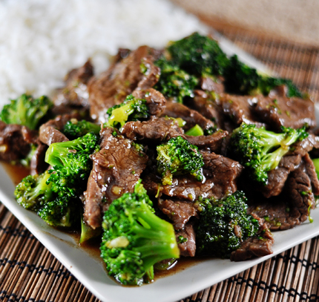
Broccoli Beef
YIELD: SERVES 4-5

INGREDIENTS
Sauce:
- 1 tablespoon rice wine vinegar
- 2 tablespoons low-sodium chicken broth
- 5 tablespoons oyster sauce
- 2 tablespoons light brown sugar
- 1 teaspoon toasted sesame oil
- 2 teaspoons cornstarch
Beef and Broccoli:
- 3 tablespoons soy sauce
- 1 1/2 pounds flank steak, cut into 2-inch-wide strips with the grain, then sliced across the grain into 1/8-inch-thick slices
- 6 medium cloves garlic, pressed through garlic press or minced (about 2 tablespoons)
- 1-inch piece fresh ginger, minced (about 1 tablespoon)
- 1 teaspoon peanut oil or vegetable oil, plus extra for cooking
- 1 1/4 pounds broccoli, cut into bite-sized pieces
- 1/3 cup water
- 3 medium scallions, sliced 1/2-inch thick on diagonal, optional

DIRECTIONS
- In a medium bowl, combine beef and soy sauce. Cover with plastic wrap and refrigerate at least 10 minutes or up to 1 hour. Meanwhile, whisk the sauce ingredients together in a liquid measure or small bowl. In another small bowl, combine garlic, ginger, and 1 teaspoon peanut oil. Set aside.
- Heat 1-2 teaspoons peanut oil in 12-inch nonstick skillet over medium-high heat until hot and rippling. Add half of beef to skillet and break up clumps; cook, without stirring, for 1 minute, then stir and cook until beef is browned around edges and cooked through, about 1-2 minutes. Don't overcook the meat - cook until just barely cooked through so the meat stays tender. Transfer beef to a medium bowl and cover with a lid and tin foil. Heat another 1-2 teaspoons peanut oil in the skillet and repeat with remaining beef.
- Add 1 tablespoon peanut oil to now-empty skillet; heat until rippling and hot. Add broccoli and cook 30 seconds; add water, cover pan, and lower heat to medium. Steam broccoli until tender-crisp, about 2 minutes. Push the broccoli to the sides of the skillet and add the garlic/ginger mixture. Cook, mashing the mixture with a spoon, until fragrant, about 15-30 seconds. Stir the mixture into the broccoli. Add the beef back to skillet and toss to combine. Whisk the sauce to recombine and add to the skillet. Cook, stirring constantly, until sauce is thickened and evenly distributed, about 1-2 minutes. Transfer to a serving platter, sprinkle with scallions, and serve - or be like me and serve it straight out of the skillet!
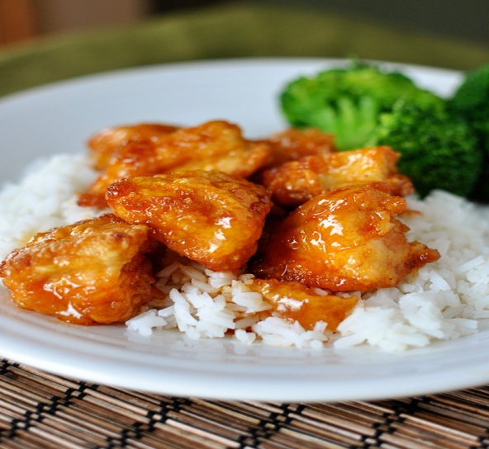
Sweet and Sour Chicken
Note: if you like extra sauce, double the sauce ingredients – pour half over the chicken and follow the recipe instructions; pour the other half in a small saucepan and cook the sauce on the stovetop at a simmer for 8-10 minutes until it reduces and thickens. Serve it on the side of the chicken.

INGREDIENTS
Chicken:
- 3-4 boneless, skinless chicken breasts
- Salt and pepper
- 1 cup cornstarch
- 2 large eggs, beaten
- 1/4 cup canola oil
Sauce:
- 3/4 cup granulated sugar
- 4 tablespoons ketchup
- 1/2 cup apple cider vinegar
- 1 tablespoon soy sauce
- 1 teaspoon garlic salt

DIRECTIONS
- Preheat the oven to 325 degrees F.
- Heat the oil in a large skillet over medium heat. While the oil is heating, cut the chicken breasts into 1-inch pieces. Season with salt and pepper. Place the cornstarch in a gallon-sized ziploc bag. Put the chicken into the bag with the cornstarch and seal, tossing to coat the chicken. Whisk the eggs together in a shallow pie plate. Dip the cornstarch-coated chicken pieces in the egg and place them carefully in a single layer in the hot skillet. Cook for 1-2 minutes and then flip each piece over to cook on the other side until nicely golden but not all the way cooked through. Place in a single layer in a baking dish and repeat with the remaining chicken pieces.
- Mix the sauce ingredients together in a medium bowl and pour over the chicken in the baking dish. Bake for one hour, turning the chicken once or twice while cooking to coat evenly with sauce. Serve over hot, steamed rice.

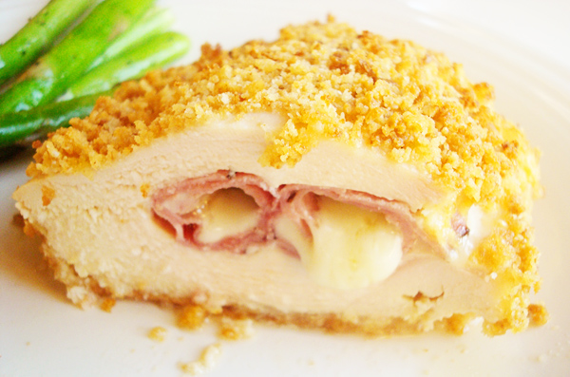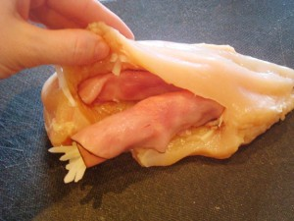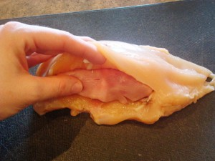
Chicken Cordon Bleu
YIELD: SERVES 4-6
Note: To make sure the cheese doesn’t leak out of the chicken while baking, use large (at least 8-ounce) chicken breasts and chill the stuffed chicken breasts in the refrigerator before breading. Make-Ahead Tip: The breaded chicken can be refrigerated covered for up to 1 day.

INGREDIENTS
- 25 Ritz crackers (I used whole wheat crackers and loved the extra nuttiness)
- 4 slices hearty sandwich bread, white or wheat (again, used homemade wheat bread and it was hearty and delicious)
- 6 tablespoons butter, melted
- 8 thin slices deli ham (about 8 ounces)
- 2 cups shredded swiss cheese
- 4 thick boneless, skinless chicken breasts (about 2 pounds total), see note
- Salt and pepper
- 3 large eggs
- 2 tablespoons Dijon mustard
- 1 cup all-purpose flour

DIRECTIONS
- Preheat the oven to 450 degrees. Pulse the crackers and bread in a food processor until they are coarsely ground. Drizzle in the melted butter and pulse to incorporate together. Transfer the crumbs to a rimmed baking sheet and bake in the preheated oven for 3 to 5 minutes, stirring occasionally, until the crumbs are lightly browned. Transfer the crumbs to a shallow baking dish (a pie plate works great!). Leave the oven on.
- Top each ham slice with about 1/4 cup shredded cheese. If your ham slices are too small, shingle two ham slices on top of each other to create a larger slice and roll the cheese up in that. Roll tightly and set aside. Pat the chicken dry with paper towels. Following the pictures below, cut a pocket in the thickest part of the chicken breast and stuff each pocket with 2 ham/cheese rolls. Pull the top flap of chicken over the rolls and press to seal (you can use a toothpick to gently secure the pocket edge, if you like). Season both sides of the chicken with salt and pepper. Refrigerate the stuffed chicken, covered, for at least 20 minutes.
- In another shallow dish or pie plate, beat the eggs and mustard. Place the flour in a third shallow dish. Remove the chicken from the refrigerator. Working with one stuffed chicken breast at a time, coat the chicken lightly with flour and then dip in the egg mixture, covering both sides. Dredge the chicken in the toasted bread crumbs, pressing lightly to help the crumbs stick to the chicken. (The breaded chicken can be refrigerated covered for up to 1 day.)
- Transfer the chicken to a lightly greased rimmed baking sheet. Bake on the lowest rack of the oven until the bottom of the chicken is browned, about 10 minutes. Move the chicken to a middle rack in the oven, reduce the temperature to 400 (you don’t have to leave the chicken out of the oven while the temperature adjusts, just put it back in the oven and then reduce the temperature), and bake until golden brown and the chicken is cooked through (160 degrees on an thermometer), about 25-30 minutes. Let the chicken rest for 5 minutes before serving.

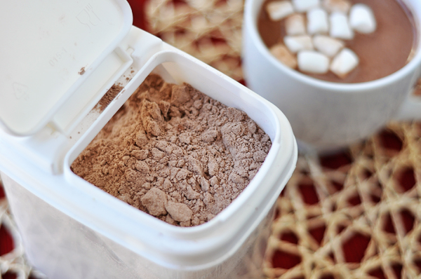
Homemade Hot Chocolate Mix
YIELD: MAKES ABOUT 20 SERVINGS OF HOT CHOCOLATE
INGREDIENTS
- 3 cups nonfat dry milk powder
- 2 cups powdered sugar
- 1½ cups cocoa powder, dutch-process or natural
- 1½ cups white chocolate chips or finely chopped white chocolate
- ¼ teaspoon salt
DIRECTIONS
- Whisk together all ingredients in a large bowl. Working in two (or more) batches, depending on the size of your food processor, pulse the ingredients in a food processor until the chocolate is finely ground. Store the dry mix in an airtight container for up to 3 months.
- To make hot cocoa, put 1/3 cup of the cocoa mix in a mug and stir in 1 cup of hot milk. Top with whipped cream or miniature marshmallows, if desired.

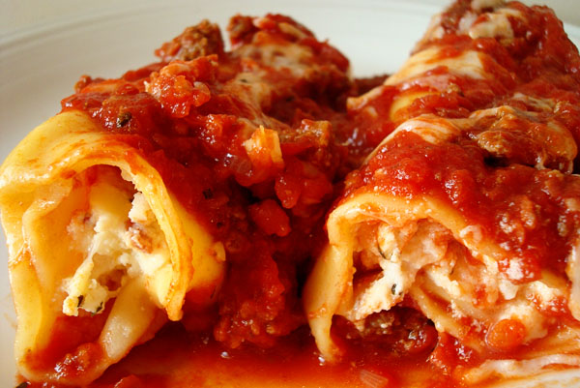
Baked Manicotti
YIELD: SERVES 6-8

INGREDIENTS
Tomato Sauce:
- 1 28-ounce can diced tomatoes (in juice)
- 1 28-ounce can crushed tomatoes
- 2 tablespoons extra-virgin olive oil
- 3 medium cloves garlic, finely minced
- 1/2 teaspoon red pepper flakes, optional
- 1/2 teaspoon salt
- 2 teaspoons dried basil
Cheese Filling and Pasta:
- 3 cups part-skim ricotta cheese
- 4 ounces grated Parmesan cheese (about 2 cups)
- 8 ounces shredded mozzarella cheese (about 2 cups)
- 2 large eggs , lightly beaten
- 3/4 teaspoon table salt
- 1/2 teaspoon ground black pepper
- 2 tablespoons chopped fresh parsley leaves (or 2 1/2 teaspoons dried parsley)
- 2 teaspoons chopped fresh basil (or 1 teaspoon dried basil)
- 16 no-boil lasagna noodles (I use the Barilla brand – apparently they are supposed to be the most similar to homemade pasta and I love them, both in this and in lasagna)

DIRECTIONS
- Adjust oven rack to middle position and heat oven to 375 degrees.
- Heat oil, garlic, and pepper flakes (if using) in large saucepan over medium heat until fragrant but not brown, 1 to 2 minutes. Stir in tomatoes, basil and 1/2 teaspoon salt and simmer until thickened slightly, about 15 minutes.
- In a medium bowl, combine ricotta, 1 cup Parmesan chese, mozzarella cheese, eggs, salt, pepper, and herbs; set aside.
- To assemble, pour 1 inch boiling water into 13 by 9-inch baking dish, then add noodles one at a time. Let noodles soak until pliable, about 5 minutes, separating noodles with tip of sharp knife to prevent sticking. Remove noodles from water and place in single layer on clean kitchen towels; discard water in baking dish and dry baking dish.
- Spread bottom of baking dish evenly with 1 1/2 cups sauce. Using soupspoon, spread 1/4 cup cheese mixture evenly onto bottom three-quarters of each noodle (with short side facing you), leaving top quarter of noodle exposed. Roll into tube shape and arrange in baking dish seam side down. (You should be able to fit 8 manicotti in each row, allowing all 16 to fit in the dish). Top evenly with remaining sauce, making certain that pasta is completely covered.
- Cover manicotti with aluminum foil. Bake until bubbling, about 40 minutes, then remove foil. Sprinkle manicotti evenly with remaining 1 cup Parmesan. Bake until cheese is browned and bubbly, about 6-7 minutes. Remove from oven and let sit for 15 minutes before serving.
- The manicotti can be prepared right up until the baking step then covered with a sheet of parchment paper, wrapped in aluminum foil, and refrigerated for up to 3 days or frozen for up to 1 month. (If frozen, thaw the manicotti in the refrigerator for 1 to 2 days.) To bake, remove the parchment, replace the aluminum foil, and increase baking time to 1 to 1 1/4 hours.

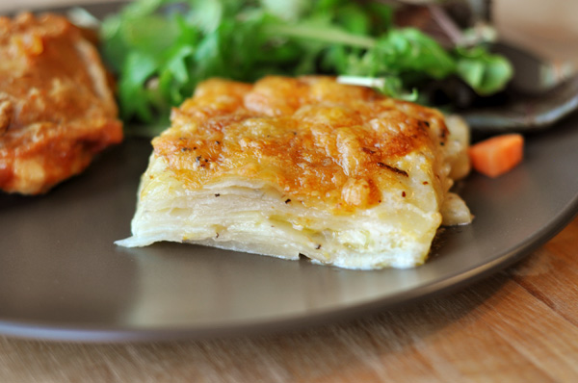
Cheesy Au Gratin Potatoes
YIELD: SERVES 6
Note: the key to this dish is the evenly sliced potatoes. It will be nearly impossible to accomplish this feat by hand, since the potatoes need to be sliced 1/8-inch thick. I don’t have a mandoline, which would work perfectly, however, a slicing disk on a food processor/shredder works great and in a pinch, I’ve used the slicing side of my box grater.
INGREDIENTS
- 1 1/4 cups shredded sharp cheddar cheese
- 1 1/4 cups shredded Monterey jack cheese
- 1/2 cup grated Parmesan cheese
- 2 teaspoons cornstarch
- 3 pounds russet potatoes, peeled and sliced 1/8-inch thick
- Salt and pepper
- 3/4 cup heavy cream
- 1/2 cup low-sodium chicken broth
DIRECTIONS
- Preheat the oven to 350 degrees and adjust an oven rack to the middle position. In a large bowl, toss the cheeses and cornstarch together until evenly coated.
- In a large gratin dish (about a 2- to 3-quart dish), shingle half of the potatoes. Sprinkle the potatoes evenly with 1 1/2 cups of the cheese mixture, 1/2 teaspoon salt, and 1/4 teaspoon pepper. Top with the remaining potatoes, shingling them neatly and evenly. Sprinkle another 1/2 teaspoon salt and 1/4 teaspoon pepper evenly over the top.
- Combine the cream and the broth in a large measuring cup and pour the mixture over the potatoes. Top with the remaining cheese mixture and bake until golden brown and a fork inserted into the center slides in easily with little resistance, 75 to 85 minutes. Let the potatoes cool for 10 minutes. Serve.

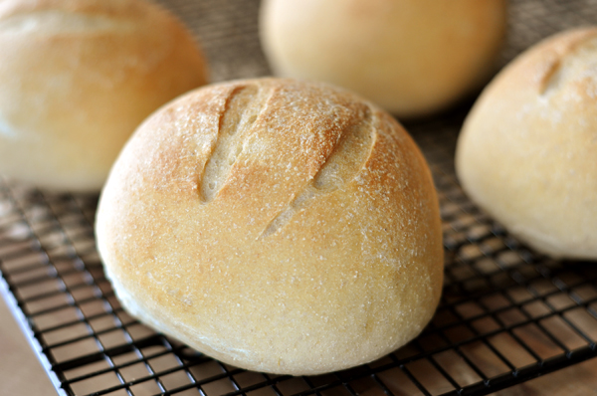
Italian Bread Bowls
YIELD: MAKES 6-8 BREAD BOWLS
As with all yeast doughs, I never use the flour amount called for in the recipe as a hard fast rule (unless a weight measure is given and then I pull out my kitchen scale). Because humidity, temperature, altitude and a multitude of other factors can impact how much flour you need in your yeast doughs, I always judge when to quit adding flour by the texture and look and feel of the dough rather than how much flour I've added compared to the recipe. This tutorial on yeast may help identify how a perfectly floured dough should be.
INGREDIENTS
- 1 1/2 tablespoons active dry yeast (use 1 tablespoon instant yeast)
- 2 1/2 cups warm water
- 2 teaspoons salt
- 2 tablespoons vegetable oil
- 7 cups all-purpose flour
- 1 tablespoon cornmeal
DIRECTIONS
- In a large bowl (or bowl of an electric mixer), dissolve yeast in warm water. Let stand until creamy, about 10 minutes. (You can omit this step if using instant yeast.)
- Add salt, oil and 4 cups flour to the yeast mixture; beat well. Stir in the remaining flour, 1/2 cup at a time, beating well with an electric mixer at medium speed after each addition until a soft but not sticky dough is formed (you may not need to use all 7 cups). This bread bowl dough needs to be a bit firmer than a roll/bread dough so that the bread bowls rise up instead of out.
- When the dough has pulled together, turn it out onto a lightly floured surface and knead until smooth and elastic, about 6 minutes (or let knead in an electric mixer). Lightly oil a large bowl, place the dough in the bowl and turn to coat with oil. Cover with a damp cloth and let rise in a warm place until doubled in volume, about 40 minutes. Punch dough down, and divide into 6-8 equal portions. Shape each portion into a round ball. Place loaves on lightly greased baking sheets sprinkled with cornmeal (or use silpat liners or parchment paper). If desired, slash the top surface of the bread bowl several times with a sharp knife or razor. Cover and let rise in a warm place, free from drafts, until doubled in bulk, about 35 minutes.
- Preheat oven to 400 degrees. Bake in preheated oven for 15-18 minutes until golden brown and baked through.

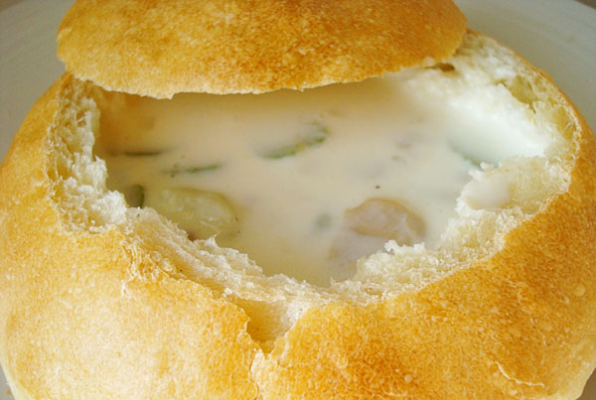
Boston Clam Chowder
YIELD: SERVES 6-8
INGREDIENTS
- 1 cup chopped onion
- 1 cup chopped celery
- 2 cups diced, peeled potatoes (I use Yukon Gold or Red potatoes)
- 3/4 cup butter
- 3/4 cup flour
- 1 quart half-and-half
- 2 (6.5-oz.) cans minced clams
- 1 1/2 teaspoons salt
- 1 1/2 tablespoons red wine vinegar
- Pepper to taste
DIRECTIONS
- Drain the clams and reserve the liquid. In a large pot, place the vegetables and pour the claim juice over the top. Add enough water to barely cover the vegetables. Simmer over medium heat until the vegetables are almost tender (don’t overcook them in this step!), about 5 minutes.
- Meanwhile, in a saucepan, melt the butter and add the flour, making a roux with a wire whisk. Constantly stirring, add the half-and-half slowly. Cook and stir until smooth and thickened, without boiling. When slightly thickened, add the roux to the vegetables and add the clams, salt, vinegar and pepper (to taste). Can keep warm (without boiling!) for a up to an hour or serve immediately.

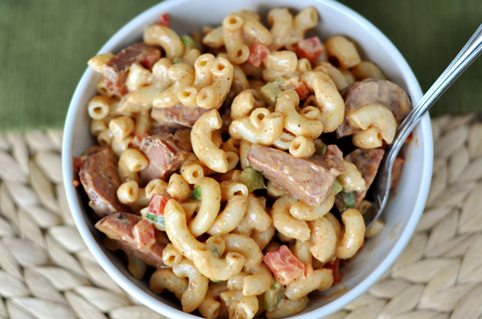
BBQ Macaroni Salad
YIELD: SERVES 8-10
Note: For a less meaty version, you can leave out the kielbasa entirely. Alternately, you can substitute many different types of meat for the kielbasa: deli ham, smoked sausage, etc.

INGREDIENTS
- 8-12 ounces turkey kielbasa, diced
- 1 pound elbow macaroni
- 1 red bell pepper, seeded and finely chopped
- 1 celery rib, finely chopped
- 4 green onions, sliced thinly
- 2 tablespoons cider vinegar
- 1 teaspoon hot sauce
- 1 teaspoon chili powder
- 1/8 teaspoon garlic powder
- Pinch of cayenne pepper
- 1 cup low-fat mayonnaise
- 1/2 cup BBQ

DIRECTIONS
- In a large nonstick skillet, heat 1 teaspoon canola oil over medium heat until shimmering. Add the chopped turkey kielbasa and cook until browned, about 5 minutes. Transfer the meat to a paper towel-lined plate and let it cool slightly before using in the recipe.
- In a large pot, bring 4 quarts of water to a boil. Add 1 tablespoon salt and the macaroni and cook until nearly tender, about 6 minutes. Drain the pasta in a colander and rinse with cold water until cool, draining again briefly. Transfer the moist pasta to a large bowl.
- Stir in the kielbasa, bell pepper, celery, green onions, vinegar, hot sauce, chili powder, garlic powder, and cayenne pepper. Let the pasta sit for about 5 minutes to absorb the flavors. Stir in the mayonnaise and barbecue sauce. Season with salt and pepper to taste and serve. The salad can be covered and refrigerated for up to 2 days. Check the seasonings before serving and stir in a few tablespoons of warm water before serving, if needed to bring the salad back to it’s creamy texture.

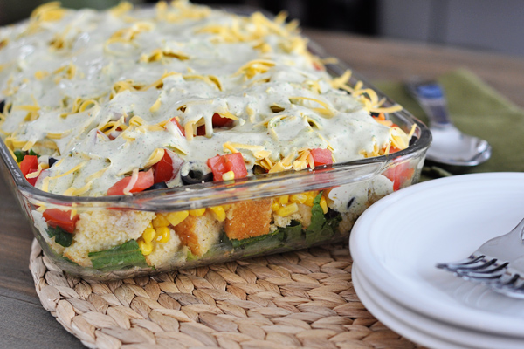
Mexican Cornbread Layered Salad
YIELD: SERVES 8-10 AS A SIDE DISH
A couple of notes: 1) make sure each ingredient is well dried before layering (like if the lettuce has been recently washed or after rinsing the beans) because you really don't want the cornbread to get soggy; major ick factor 2) I made an adapted version of my favorite cornbreadfor this recipe, reducing the sugar to 1/3 cup and using 1/2 cup coconut oil. I cut the cooled cornbread into small cubes. I had a bit leftover after I measured out the 3 or so cups - makes a great snack! 3) this salad can be layered in a variety of ways. If you want more dressing throughout the salad, add 1/2 of the dressing part way through the layers. You can also use a trifle dish to layer this but I like using a 9X13-inch dish because if you are scooping it out for a crowd, it's much easier to get all the ingredients in one scoop versus scooping into a really deep dish. Make sense? 4) adding grilled chicken to this (or on the side) would make a fantastic main course.

INGREDIENTS
Salad:
- 3 cups chopped romaine lettuce
- 3 cups cubed or crumbled cornbread (see note above)
- 1 (15-ounce) can black beans, rinsed and drained
- 1 1/2 cups corn kernels (fresh or frozen, thawed if frozen)
- 1 red bell pepper, small diced
- 1 (15-ounce) can black olives, drained and sliced
- 3 green onions, finely chopped
- 4 roma tomatoes, liquid squeezed out and chopped
- 2 cups shredded cheddar cheese
Dressing:
- 1/3 cup regular or light mayonnaise
- 1/3 cup light or regular sour cream or plain yogurt
- 1/3 cup lowfat buttermilk
- 3/4 cup chopped fresh cilantro
- 1/4 cup fresh lime juice (from about 2 limes)
- 2 teaspoons ground cumin
- 1/2 teaspoon salt
- 1 teaspoon chili powder

DIRECTIONS
- In a blender, combine all the dressing ingredients until smooth. Refrigerate until ready to use (this can be made several days in advance).
- In a 9X13-inch pan, layer the ingredients in the following order: lettuce, cornbread, beans, corn, red pepper, olives, green onions, tomatoes and cheese.
- Pour the dressing over the cheese. Cover with plastic wrap or foil and refrigerate for 1-2 hours. Serve chilled.

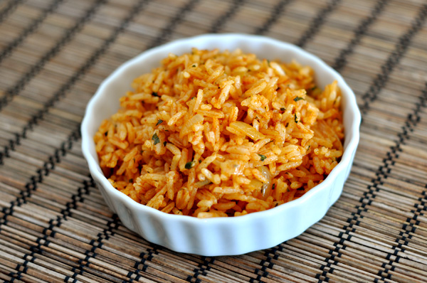
Mexican Rice
YIELD: SERVES 4-6
INGREDIENTS
- 1 cup of long grain white rice
- 2 cups of low-sodium chicken broth
- 1 tablespoon of olive oil
- 1 small yellow onion, diced
- 4 cloves of garlic, finely minced
- 1/4 cup of tomato paste
- 1 tablespoon of lime juice, from about 1 lime
- 1/2 cup of freshly chopped cilantro
- 2 teaspoons cumin
- Salt to taste
DIRECTIONS
- In a medium-sized pot, add rice and chicken broth. Bring to a boil over high heat. Stir. Cover the pot, lower the heat to low and simmer for 17-20 minutes. Remove from heat and keep the pot covered for 5 more minutes.
- While the rice is cooking, heat the olive oil in a large nonstick skillet over medium heat. Cook the onions in the hot oil for 10 minutes, until translucent and starting to brown. Add the garlic to the skillet and cook for one minute, stirring constantly. Stir in the tomato paste and cumin and cook for another minute or two. Mix in hot, cooked rice, lime juice and cilantro. Mix until well combined. Season to taste with salt. Serve immediately.

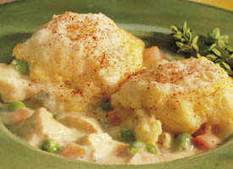
Quick Chicken and Dumplings

Ingredients
- 1 1/2 cups milk
- 1 cup frozen green peas and carrots
- 1 cup cut-up cooked chicken
- 1 can (10 3/4 ounces) condensed creamy chicken mushroom soup
- 1 cup Original Bisquick® mix
- 1/3 cup milk
- Paprika, if desired

Directions
- 1Heat 1 1/2 cups milk, the peas and carrots, chicken and soup to boiling in 3-quart saucepan, stirring frequently.
- 2Stir Bisquick mix and 1/3 cup milk until soft dough forms. Drop dough by 8 spoonfuls onto chicken mixture (do not drop directly into liquid). Sprinkle with paprika.
- 3Cook uncovered over low heat 10 minutes. Cover and cook 10 minutes longer.

Tips & Techniques

Substitution
You can use 1 cup of your favorite frozen vegetable combination instead of the peas and carrots.

Success
For tender dumplings, don’t overmix the dough. Mix just until moistened.
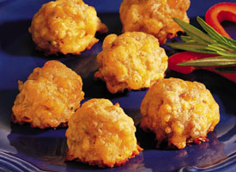

Sausage and Cheese Balls
Makes about 7 dozen

Ingredients
- 3 cups Original Bisquick® mix
- 1 pound bulk pork sausage
- 4 cups shredded Cheddar cheese (16 ounces)
- 1/2 cup grated Parmesan cheese
- 1/2 cup milk
- 1/2 teaspoon dried rosemary leaves
- 1/2 teaspoon parsley flakes
- Barbecue sauce, if desired

Directions
- 1Heat oven to 350ºF. Grease jelly roll pan, 15 1/2x10 1/2x1 inch.
- 2Stir together all ingredients, using hands or spoon. Shape mixture into 1-inch balls. Place in pan.
- 3Bake 20 to 25 minutes or until brown. Immediately remove from pan. Serve warm with sauce for dipping.

Tips & Techniques

High Altitude (3500-6500 ft)
Heat oven to 375ºF. Decrease Bisquick to 2 1/2 cups; stir in 1/2 cup Gold Medal® all-purpose flour. Bake 25 to 30 minutes.
- "Go ahead and mix this with your hands if you like. It makes it easier to work with."
- "If you happen to have a 12-ounce tube of frozen sausage on hand, you can use it instead of 1 pound."
- "I like to serve this with barbecue sauce or sweet and sour sauce."
Make these popular sausage-cheese balls up to a day ahead of time and refrigerate. Bake as directed.

Substitution
You can use 1 1/2 teaspoons chopped fresh parsley instead of the parsley flakes.

Variation
For holiday ham balls, use 1 1/2 cups finely chopped fully cooked ham instead of the pork sausage, omit the rosemary and add 2 tablespoons parsley flakes and 2/3 cup milk. Mix and bake as directed in the recipe.

Success
It's true. You don't need to cook the sausage before using it when making this recipe.

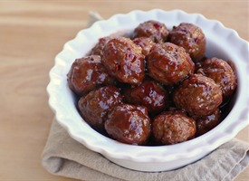

3-Ingredient Sweet and Sour Meatballs
Hearty sweet and sour meatballs with only 3 ingredients that are party favorites.

Ingredients
- 1 (12 ounce) jar of chili sauce
- 1 1/2 cups grape jelly
- 2 pounds (32 ounces) frozen meatballs

Directions
- 1Pour meatballs into a slow cooker. Combine jelly and chili sauce in a small bowl and pour over meatballs.
- 2Cook on low for 3-5 hours or until meatballs are heated through.
- 3Serve with toothpicks.

